Year 3/4
Summer
1 & 2 2022
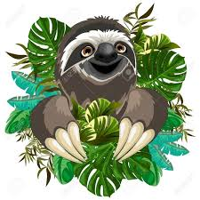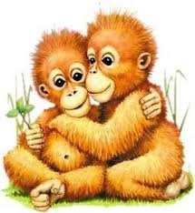
Welcome to the Jungle!

Maths
As amazing Rock Stars, we will continue to ‘Rock’ our Times Tables and we ask that your child continues to log on and ‘rock out’ at home.
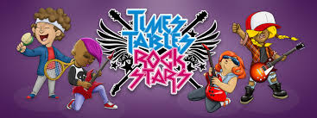

Fractions & Decimals
We will continue to work with fractions and decimals as we learn the rules for adding and subtracting.

Capacity, Mass, Time & Money
We will develop our understanding of the world around us and learn to read different scales as well as adding and subtracting different amounts.

Geometry, Shape & Position and Direction
We will develop our understanding of shape in the everyday world: recognising shapes, understanding their properties and learning to classify and read the measurement of angles.
We will also cover statistics.
English
Fiction
We will explore Shaun Tan’s ‘The Lost Thing’ and write a story about something lost that wants to be found.

Factual
We will study news reports in print, on the internet and the television. We will write a news report about an endangered rainforest creature. We will also write a letter to an MP about deforestation,

Poetry
We will learn, recite and write our own rainforest haikus and kennings.

Grammar, Punctuation & Spelling
We continue to learn spelling patterns. We will also continue to proofread and edit our own writing whilst improving our understanding of vocabulary, word classes, punctuation, tenses and conjunctions.

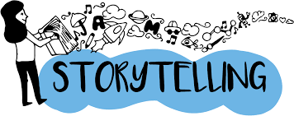

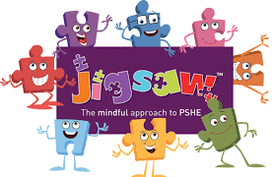
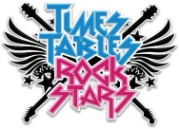
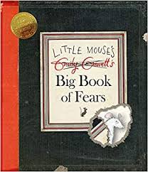
Topic work

Science – Our topic is ‘roots and shoots’ – we will learn how plants grow and reproduce.
Geography – We will learn all about Earth’s amazing and beautiful rainforests
Computing – We will learn about branching databases and how to organise data effectively
PE – This term, we will take part in rounders and athletics. Year 3s will also go swimming.
Art & DT – We will learn about the work of Georgia O’Keeffe and Henri Roussea and recreate their style in our own drawings and paintings. We will also design, make and evaluate poison dart frog bean bags
French – We will learn to say ‘I Can’ in French and explore the story of Little Red Riding Hood
Music – We will look at how music (disco music in particular) can bring people together
RE – What do different people believe about God? We will look at the beliefs of Hindus, Christians and Muslims

ICT
Children will explore the usefulness of the internet when researching topics. They will learn effective research techniques and how to quickly evaluate a site for reliability and usefulness. They will also learn how to create a PowerPoint presentation.

PHSE/Well-Being & SRE

Following the Jigsaw scheme: we will explore our relationships and friendships by thinking about who we value and how we demonstrate friendship, kindness and tolerance. We will investigate how our bodies change as we grow up; understanding that everyone is unique and special. We will discuss how changes make us feel and who to talk to if we are worried about any changes we experience.
Please see our school website for details of SRE learning for our year group.



