LO: Solve problems involving time.
Bart leaves for football at 10 o’clock.  It takes him half an hour to walk there.  What time does he get there?  Draw the time on the clock. |  | 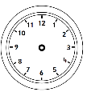
Laura goes swimming at 9 o’clock. She swims for 2 hours. What time does Laura get out of the pool?  Draw the time on the clock. | 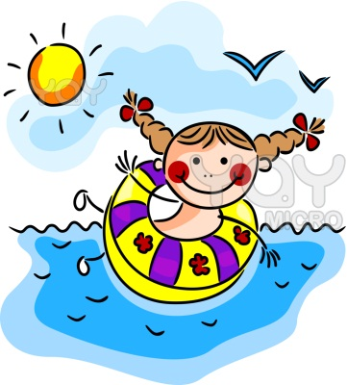
The Angry birds go to the cinema. They arrive at 4 o’clock. The film lasts one hour. What time do they leave the cinema? | 
Hello Kitty goes shopping. She goes on the bus which takes 1 hour. If she gets to the shops at 11 o’clock, what time did she set off? | 
The children start dancing at 5 o’clock. They finish two hours later. What time do they finish dancing? | 

