Name:…………………………………………………………………… Date……………………………………
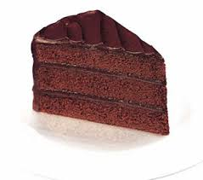
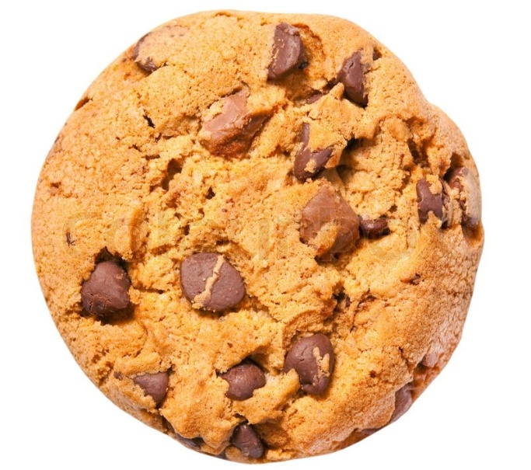
L.O: solve two-step problems using money
£2.45
£1.42

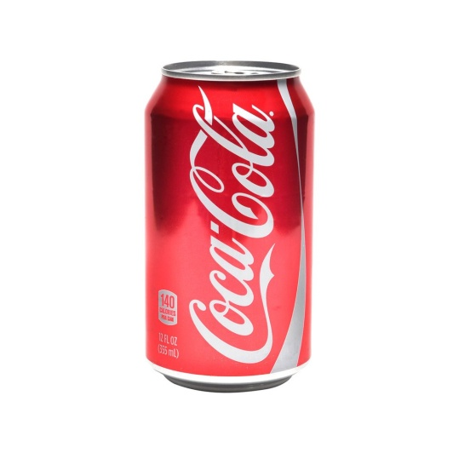
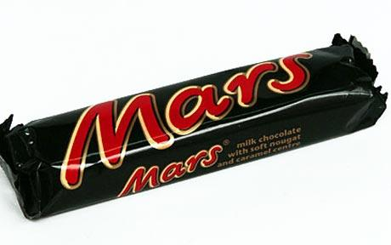
Put the title of your challenge as a sub-heading in your book and record all your workings clearly underneath. Make your answer clear at the end…
Final Challenge:
If James had spent £20 and received £16.36 change, which three items must he have bought?
Challenge Two:
When he gets home, Aunt Spiker demands that James buy her three unhealthy snacks from the shop! What change might he have to give his other aunt if she gives him £10?
Challenge One:
James’s Aunt Sponge gives him £5 to spend on some sugary food for a treat for herself! What would you pick if you were James and how much change will you need to give back to Aunt Sponge?
84p
76p
£1.38

