A Timeline of Significant People in the Past
Option 1: Place pictures of Florence Nightingale, Edward Jenner, Louis Braille and Isambard Kingdom Brunel on a timeline in birth order.
Option 2: Pick just one of the famous names above, research their life and add all significant events and dates onto the timeline.
Option 3: As option 1 but adding facts about deaths and/or other significant dates in their lives from your own research.
Option 4: As option 3 and then research one other significant person in the past and add their details as well.

Select which option is most appropriate for your child (at school we would generally suggest Year 1 do option 1 or 2 and Year 2 choose option 2, 3 or 4 to give them the appropriate level of challenge/support – however it is entirely up to you as you will be doing this at home!)

You can complete the timeline below using facts, pictures (drawn or printed) and dates OR you can produce your own timeline however you like. Suggestions for this could be adding your information using the washing line in the garden, string or chalk on the patio (if allowed!) and placing/pegging pictures, facts and dates to it.

You are welcome to source your own resources but here are a few pictures to help you if you would like them…
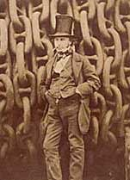
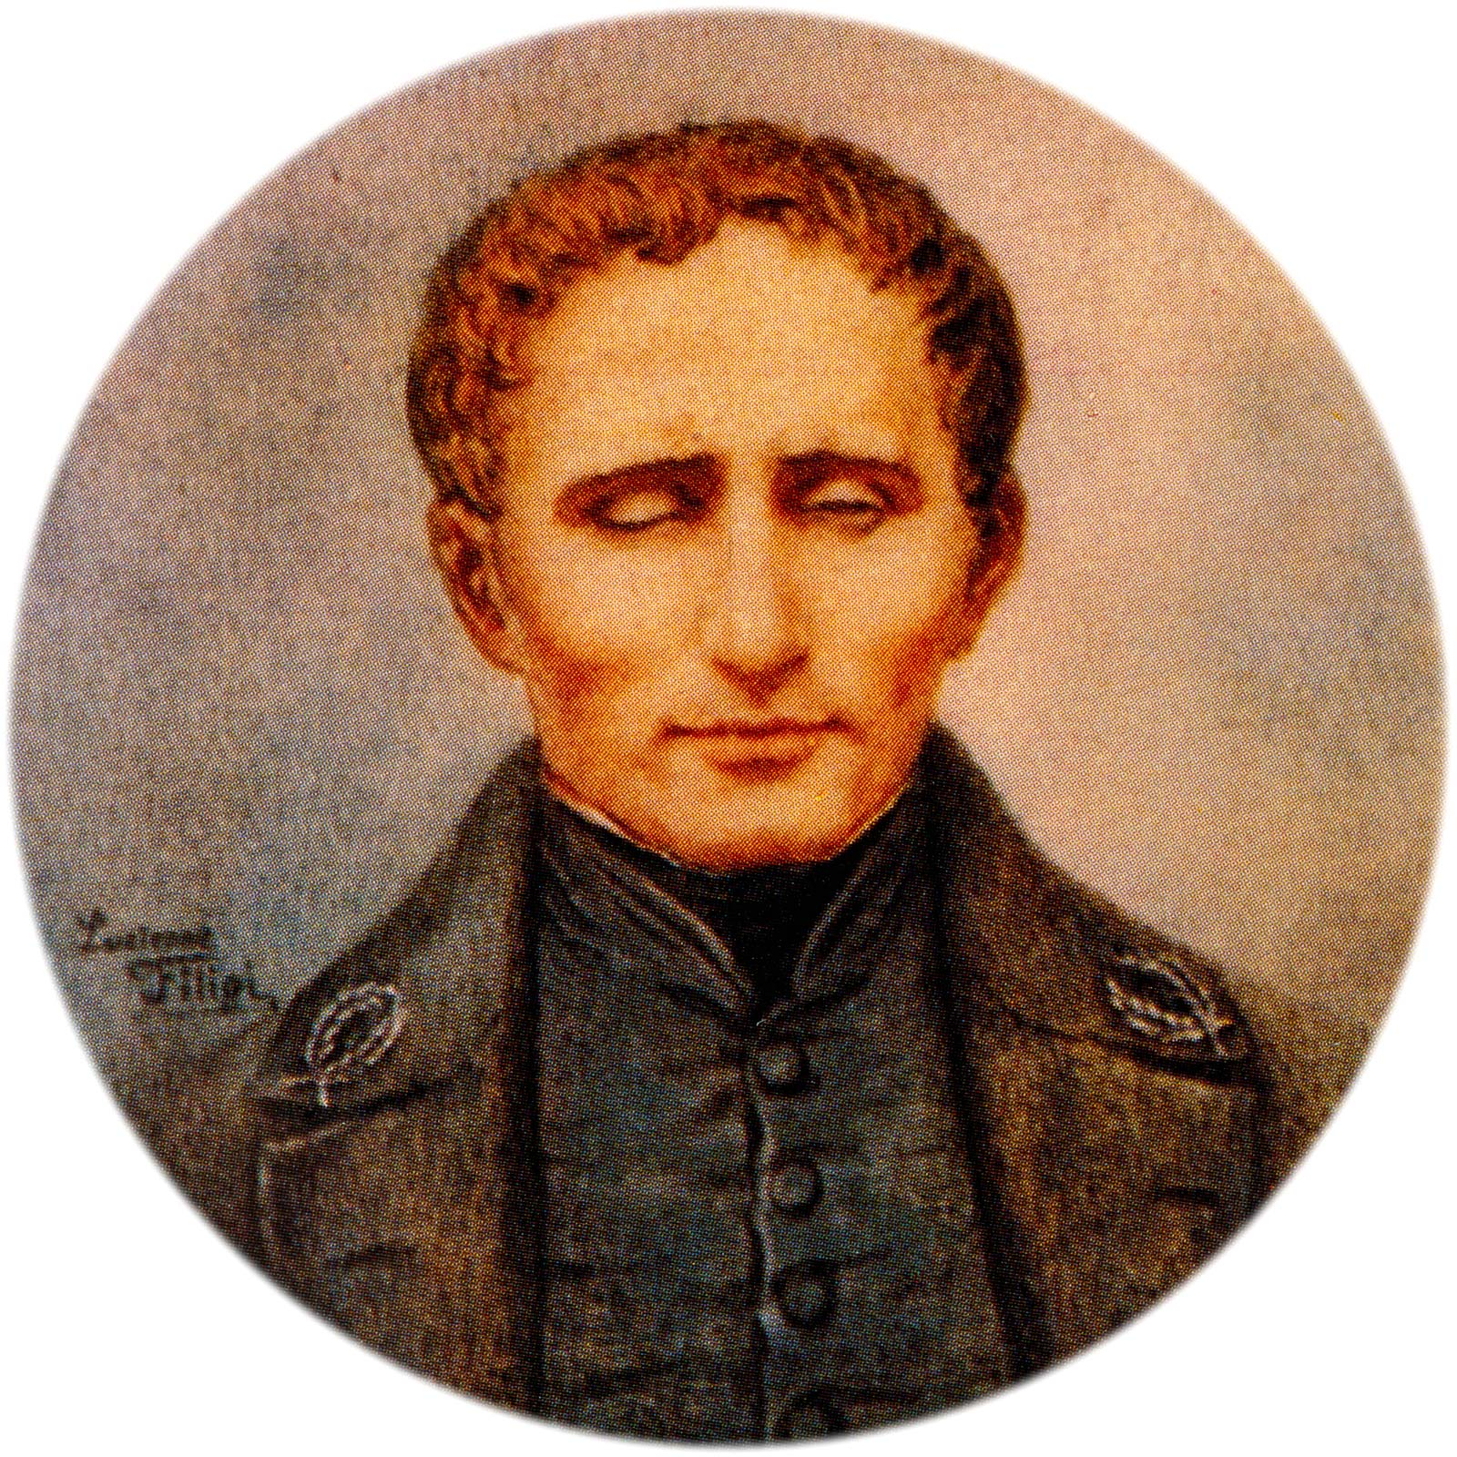
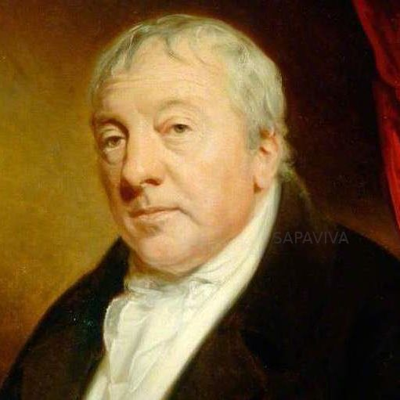
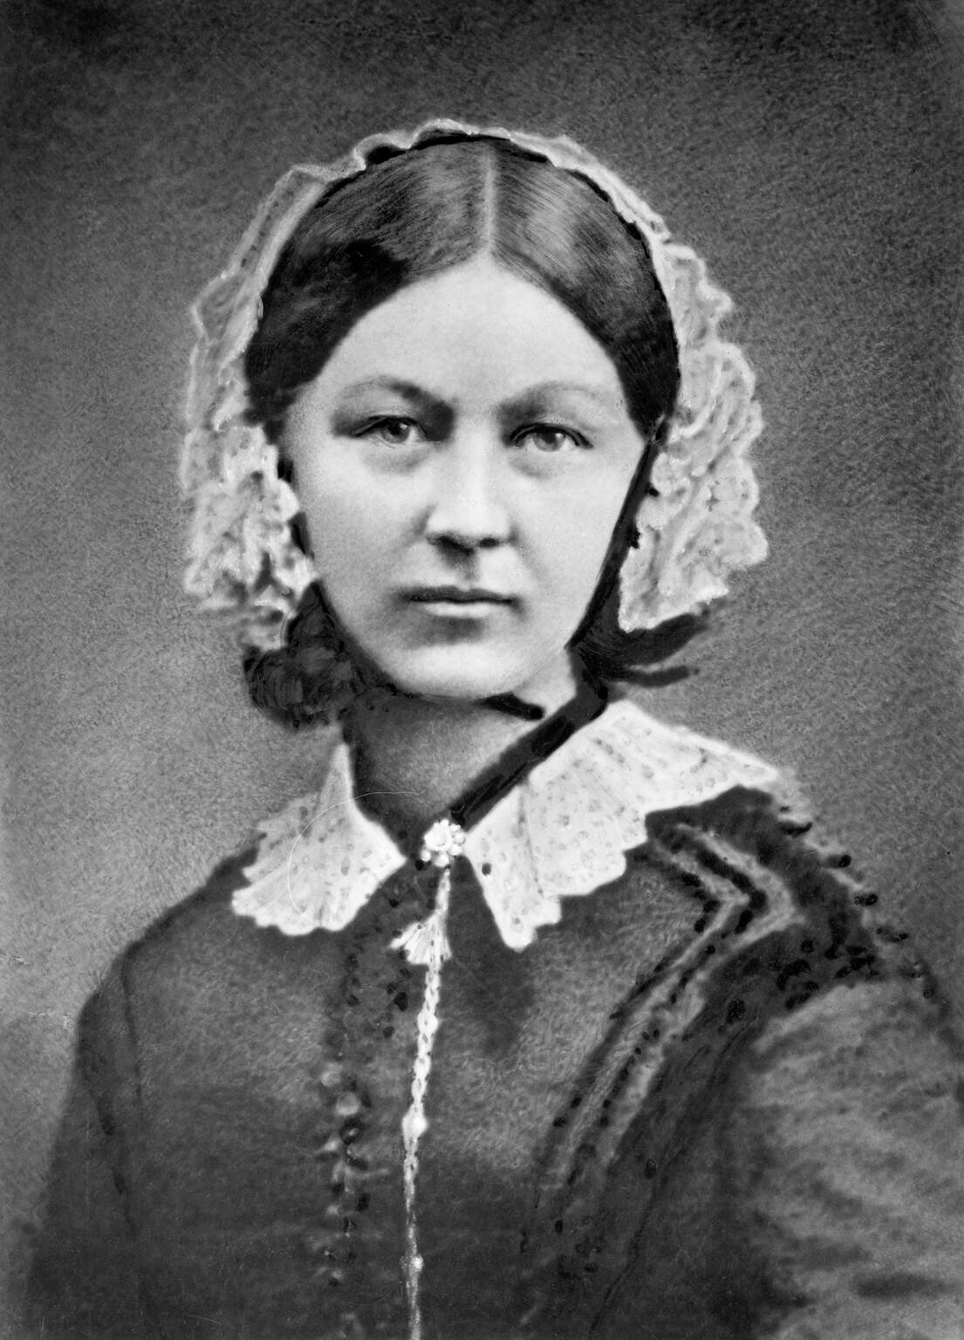

Florence Nightingale Edward Jenner Louis Braille Isambard Kingdom Brunel
(1820 – 1910) (1749 – 1823) (1809 – 1852) (1806 -1859)

1749
I I I I I

Useful websites and resources:

- Purple Mash (all except Louis Braille)
- Twinkl resources (we have provided some for you but there are more)
- www.bbc.co.uk/bitesize/primary (all four famous people – for Louis Braille just type ‘Braille’)
- www.britannica.com (all four famous people)
- www.bbc.co.uk/historicfigures (all four famous people except Jenner)
- www.bbc.co.uk/teach (all except Edward Jenner at the moment)
- Magic Grandad videos on Youtube and some on BBC

- Louis Braille reading text and comprehension questions (sent home alongside this)
- World Braille Day worksheet (sent with this)
- Brunel Fact files (sent home with this)

- www.florence-nightingale.co.uk/florence-nightingale-biography

- National Geographic Kids (Florence Nightingale)

- Wikipedia has information about all four famous people but can be inaccurate sometimes (dates and the general information appears to be correct)

