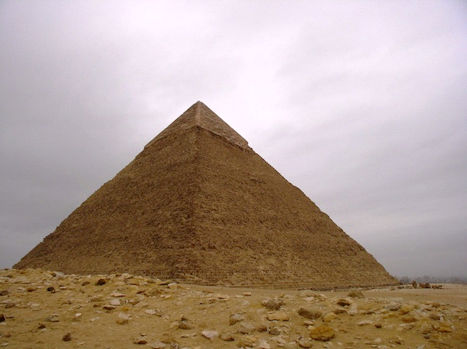
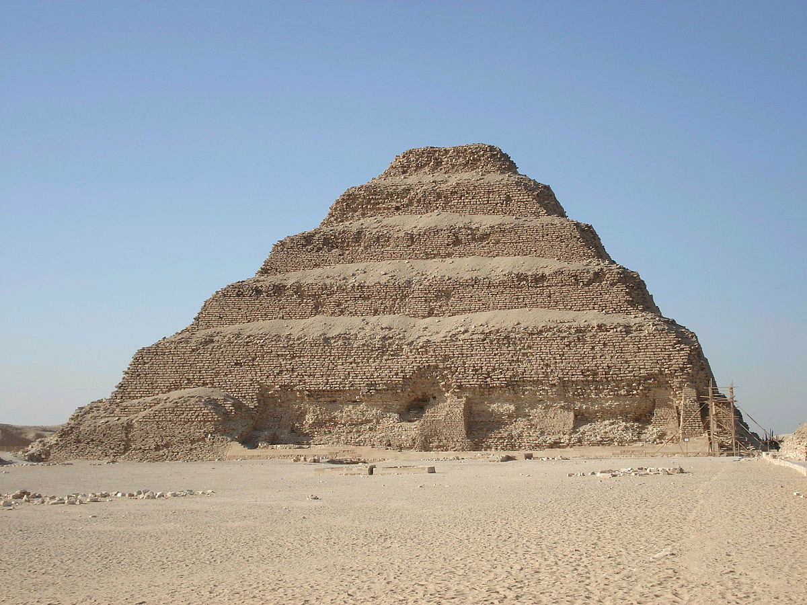
Money Pyramid

Can you find different ways to make the same amount?
You can draw them or place real coins on the grid.

Put your coin here…
20p, 50p, £1, £2…

Each box represents a coin. So 2 boxes = 2 coins to make the amount, 3 boxes = 3 coins… Can you fill every layer on the pyramid?

If you want a challenge you can use a £5 note!

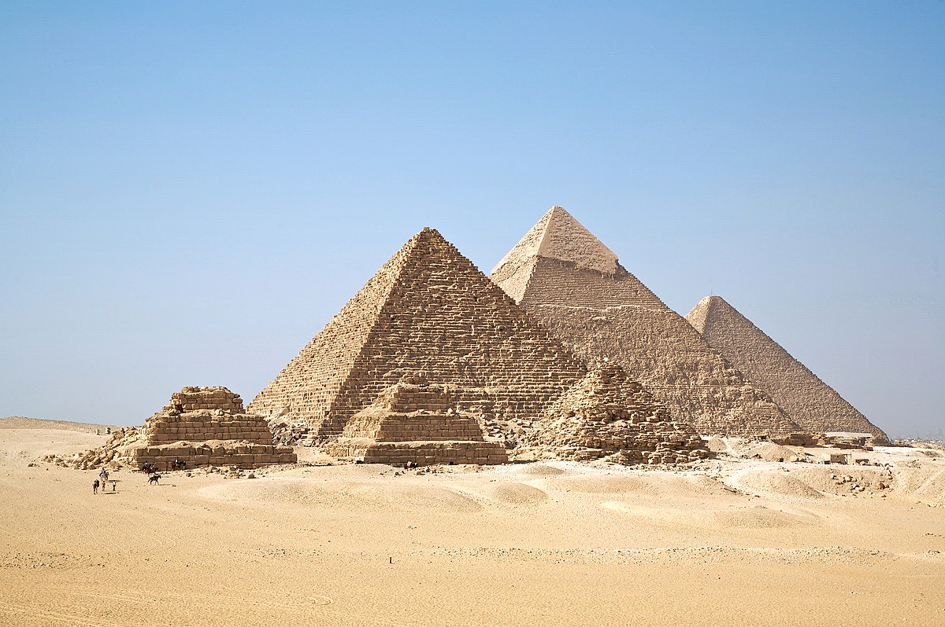
History Link: Research the ancient Egyptian pyramids if you like…

Are there any other ways that you haven’t thought of?
Try again with a different coin at the top…
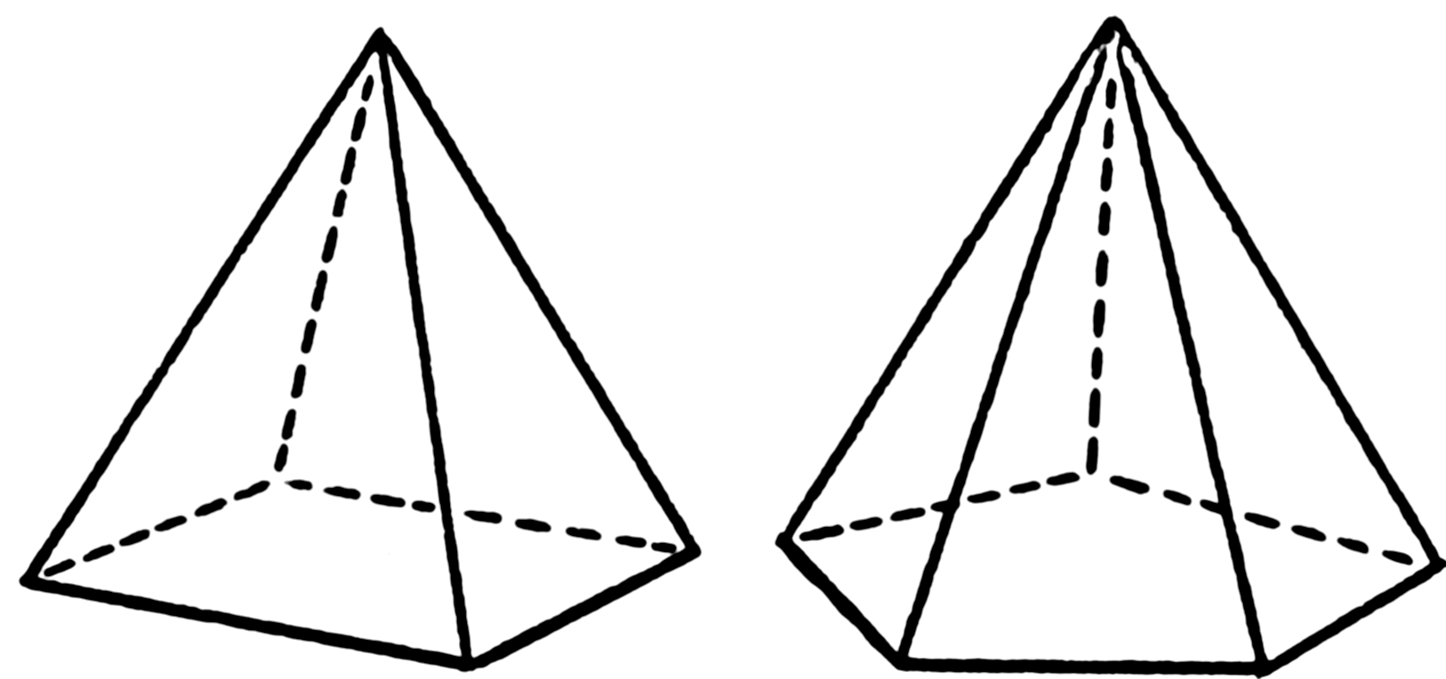
3D Shapes: Investigate different types of pyramid…
How many faces, edges and vertices (corners) do they have?

