24-Hour and 12-Hour Time

- Convert the following 12-hour times to 24-hour time.
12:00 p.m. = |  |  | 10:30 p.m. =
3:20 a.m. = |  |  | 12:05 a.m. =
7:50 p.m. = |  |  | 5:25 p.m. =

- Convert the following 24-hour times to 12-hour time.
1643= |  |  | 0230 =
0520 = |  |  | 0000 =
2040 = |  |  | 2100 =

- Show the given 24-hour time on the analogue clock.
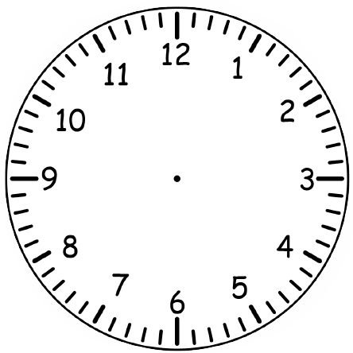 | 0520
 | 1430
 | 2340
 | 0350
 | 1915
 | 0025

- If I got home at 17:30 and went to bed at 21:30, how long was I at home before I went to bed?
- A car race began at 08:45 and finished at 14:00. How long did the race last?

Think Solve Explain:
Who has made the mistake? Explain your answer.
No, we ate lunch at 12am.
We ate lunch at 12pm.
Harriet Myles

