Year 3/4
Rainforest song:  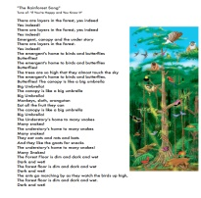  Write the words for a rainforest song, that people could sing around the forest whilst the rain falling. | River chocolate bar:  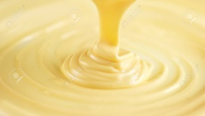  Create a chocolate bar by melting white chocolate, swirling different food-colouring and adding different toppings. Give it a forest-inspired name and design a wrapper. | Rainforest tools:  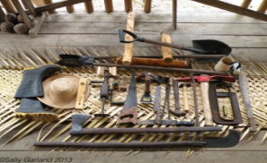  Make a mock set of tools you would use to make your way through the rainforest – describe why you need them. | Rainforests poem:  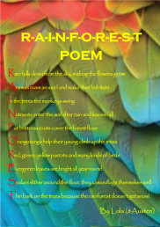  Write a poem describing the rainforest – what you see, hear, smell, taste and feel.
Interview:  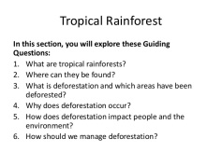  Write a list of 10 questions which you would ask a tribe who live in the rainforest. | Map:  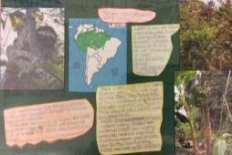  Create a map of the rainforest and how you would get around | Fact-file:  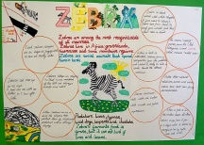  Write a fact-file about an animal you will find in a rainforest, make sure to draw pictures. | Letter:  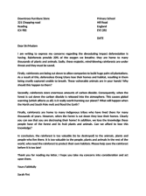  Write a letter from an endangered animal in the rainforest. What do you need people to do so that you survive?
Poster:  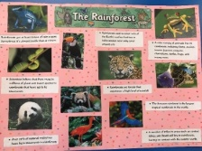  Create a poster of all the rainforest animals – use it to inform people why we need the forests. | Plan:  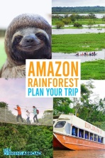  Plan the trip of a lifetime to the Amazon rainforest. Use the internet to create a travel brochure with prices and activities. | Model:  Create a model of a rainforest in a shoe box.  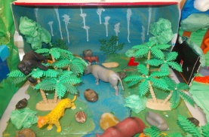 | English and DT skills:  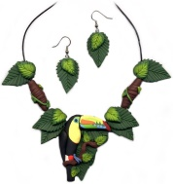  Design some rainforest jewellery and explain what is it made out of and why you chose those materials. Make a rainforest inspired case to display it.
Maths skills:  Make up some rainforest inspired maths problems or use Purple Mash to code a rainforest inspired game. | Art skills:  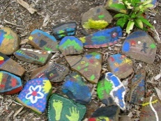  Gather some clean, large pebbles and clean. Paint them with rainforest animals and ‘kind’ words. | Cross-word:  Create a cross word full of rainforest words, list them at the bottom and complete it with a friend. | Painting:  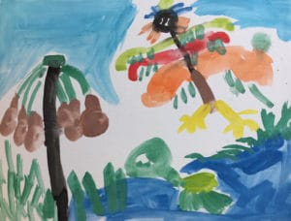  Create a painting using only things you would find in the rainforest, pebbles, leaves, twigs, ‘animal paws’ which you can make with your hands.
Welcome to the Jungle!

 Science Ideas 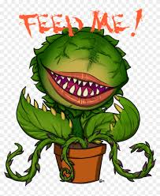
Our science topic this term is all about plants. Check out these websites and have a go at some of the plant and fruit based experiments.
Don’t forget to take pictures to show us.
https://thekindergartenconnection.com/must-try-plant-activities-kids-will-love/
https://sciencing.com/fruit-themed-science-activities-7953916.html
https://www.kiwico.com/diy/explore/plant-science
https://greensborosciencecenter.wordpress.com/2017/04/20/diy-science-light-maze/
https://www.stem.org.uk/resources/collection/84753/primary-science-investigations-plants

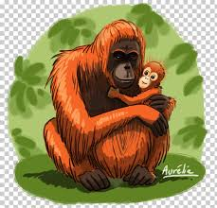 Rainforests 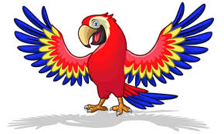
To help you with our Rainforest topic you might find these websites useful:
London Zoo www.zsl.org/exhibits/rainforest-life
Chester Zoo https://www.chesterzoo.org/virtual-zoo/
Amazon 360 tour https://www.iflscience.com/environment/explore-the-amazon-with-this-stunning-360-virtual-reality-video/
Amazon rainforest http://www.pbs.org/journeyintoamazonia/index.html
San Diego Zoo https://animals.sandiegozoo.org/habitats/tropical-rain-forest
Rainforest artist https://www.ducksters.com/biography/artists/georgiaokeeffe.php and https://www.tate.org.uk/kids/explore/who-is/who-georgia-okeeffe
Rainforest facts http://www.primaryhomeworkhelp.co.uk/rainforest.html
Rainforest plants http://www.srl.caltech.edu/personnel/krubal/rainforest/Edit560s6/www/plants.html
Rainforest animals https://www.rainforestanimals.net/
Rainforest facts and ecotourism http://www.eduweb.com/amazon.html
Rainforest facts and activities https://www.enchantedlearning.com/subjects/rainforest/
General http://www.lizasreef.com/HOPE%20FOR%20THE%20RAIN%20FORESTS/rain_forest_just_for_kids.htm
National Geographic https://www.natgeokids.com/uk/discover/geography/physical-geography/15-cool-things-about-rainforests/
Games and information https://www.rainforest-alliance.org/kids

