A rainbow of feelings
Context:
This activity is designed to be used with primary children returning to school. It can be used to reflect on their experience of lockdown and then revisited to explore their feelings about school and home as things change.
It simple enough to be used with a range of ages. Adapt the language used to be appropriate for your age group. Even though it is simple, these activities can open-up some deep discussions, so use the resources as a starting point. They can be effective even with Yr6.

Aim:
- To give children a space to explore their feelings and reflect on the past few months
- Understand that a range of feelings is normal and healthy
- Understand that people can have different feelings about the same situation
- Accept each child’s emotions and experience in the current pandemic

Introduction:

- Who put a picture of a rainbow in their window during lockdown? Have a discussion about the different types of rainbows children made, or have seen. Different sizes, different materials used, different places they were put.

- What do we notice about all of them? They are all different, unique; yet all were equally important and valid, from a toddlers scribbling to a professionally painted window scene.

- Feelings are like a rainbow – we all have many different feelings and show them in many different ways. But they are all equally important and valid. We are going to take some time to explore this together.

- Safety check – some of us might have had some really hard experiences or feelings during lockdown. No-one is going to be asked to talk about anything they don’t want to. If during this activity anyone feels they need to take a break, just give me a wave. If afterwards you would like to chat quietly with me or someone else about anything, just let me know.

Story:
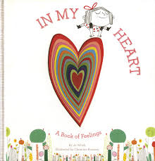
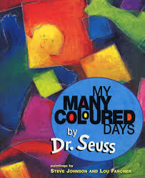
Read together a good book or a poem about feelings. You may have a favourite. Here are a few we like:

- My Many Coloured Days, by Dr Seuss. - This one works best, as it introduces the link between colours and feelings.

- In My Heart, by Jo Witek - This one doesn’t make a direct link with colours, but you can have a discussion about the choice of colours used on each page.

Both of the above have readings on Youtube, which you could use if you do not have the book.
- A Nifflenoo Called Nevermind by Margot Sunderland 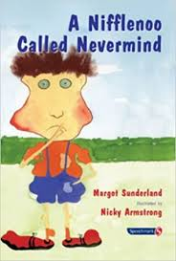

- I can Feel A Rainbow – poem available on twinkl
- tes.com has short poems on various feelings for Yrs 5&6

Discuss the story or poem together. Which part did you like best? Any parts you did not like?

Application:

What feelings do you think some children may have felt during their lockdown time at home? Have a group discussion. Accept all feelings, emphasising ‘some children may have felt... others may have felt…’ Teacher may want to make a list on the board of feelings children suggest, or give examples of their own experience. Keep it indirect, unless a child offers feelings about themselves.

If each of these feelings was a colour, what colour would it be? Accept all suggestions, emphasise people may associate different colours with different feelings.

My feelings:
- Close your eyes and think about your feelings during over the last few months. Which were big or frequent feelings, which were small or occasional. Imagine each as a colour.

- Make a key for each of their feelings and their associated feeling on the body template sheet.

- Then colour in the body to show how much they felt those feelings or how strong they were. Eg. If they felt lots of anger they may have lots of red. Children may also want to associate the feeling to an area of the body eg. they may colour grey in their middle, as they got tummy ache when worried, or red in their arms because they wanted to punched things when they got angry.

- Remind them, everyone’s feelings will be different, so everyone’s picture will be different.

- Give space for anyone to show or explain their picture if they would like to. No pressure to share.

Relaxation:

Some children may have found this hard, it may have bought up strong feelings, or reminded them of difficult experiences. Take some time to do a relaxation exercise as a group. Here’s one we like:

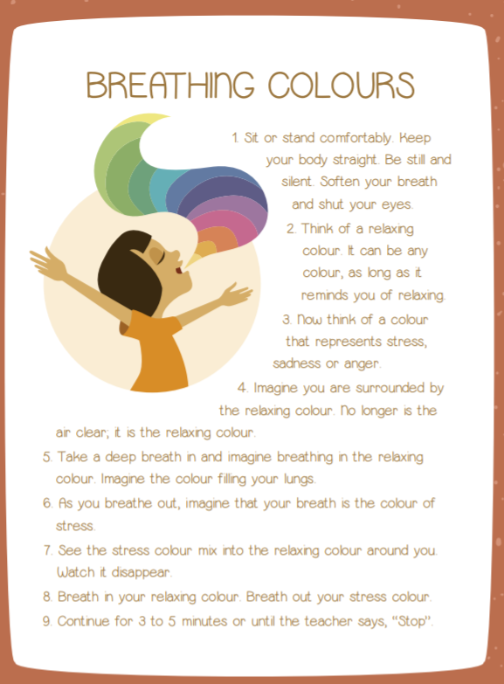

Ending:

Remind the children they can talk to you or another grown-up they trust about anything, no matter how big or small.

Extension:

- You may want to take it further by exploring what different children do when they feel different feelings and share strategies that help. A good book to help with this is: How are you feeling today? By Molly Potter. You could make your own version with children in your group, sharing ideas that work for them.

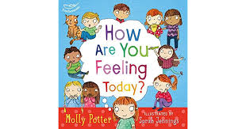

- you may want to invite the class to colour another body thinking about a specific thing – eg. How it feels to be in school with all the distancing rules or transition to secondary school.
- Use the ‘Feelings Thermometer’ and ‘My Feelings in Lockdown’ worksheets to explore and discuss their feelings further.

My Feelings
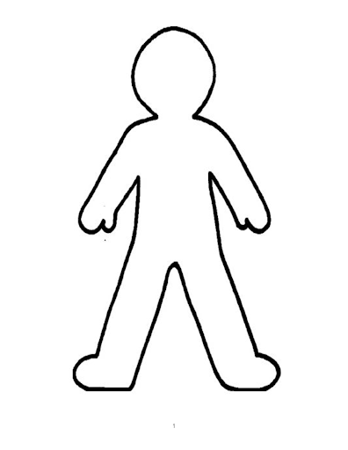
Key:
Colours | Feelings

-

