My Lockdown Experience

Context:
This activity is designed to be used with primary school children returning to school. For most children it will have been a long time since they have had any contact with their teachers and friends. Children may have changed or feel different because of their lockdown experiences. They may have experienced some very lovely, very difficult or very boring times. Every child’s experience will be different. In order to begin re-building these relationships, we need to take some time to understand what the experience was like for each child and to get to know them again.
Use these simple worksheets to help begin this process, using them in whatever way is appropriate for your age group. But remember, for some children it may take a long time before they can talk about things that have happened. These worksheets and discussions are only the starting point. Try to keep open to children talking about their experiences, even months later.
Be aware that these discussions may highlight safeguarding issues, or experiences that may need some specialised support, such as bereavement counselling. Ensure you know your current procedure for safeguarding and refer any concerns or needs in line with your school’s policy.
You could use these activities as one lesson, or as individual activities at different times.
Aim:
- Give children time to reflect on their experience during lockdown
- Encourage children to talk about these experiences
- Affirm that every child’s experience will be different and each is valid

- Introduction:

- Use the ‘I am feeling thermometer’ below and ask each child to reflect on how they are feeling today.
- Encourage them to share with the class or in pairs, if they are happy to do so.
- Refer back to the Rainbow of Feelings activity, if you have done it, thinking about the colours relating to each feeling.
- Be aware of any children who are already feeling vulnerable or finding today difficult. This may impact the way they respond to the activities below.

- Explain, we are going to think about our time at home during lockdown. Everyone’s experiences will be different, that is ok.

- What I did in lockdown/ how things were:
- Ask the children to brainstorm things they did during lock down, or the way things were for them. Encourage them to group them into things they liked and things they didn’t like. You could have a whole group discussion initially and then use the sheets below to help them put down their individual thoughts.

- Encourage the children to their experiences, if they are happy to. You could draw out similarities and differences across the group.

- How I felt about lockdown:
- Ask the children to think back to the feelings thermometer and pick out the main feelings that they experienced during the lockdown.
- Ask them to use the coloured worksheets below to write or draw in more depth about these feelings and their experiences. The worksheets are coloured to link with sections of the feelings thermometer, but they can focus on any feelings they choose.
- Some example sheets are included below, which you could read together first.

- Moving on from lockdown:

- With many changes to children’s normal lives, if may be easy to focus on the negative feelings and experiences they may have had.
- Using the sheets below, encourage the children to think about the positives of their time away from school. Allow them time to highlight those experiences that they would like to keep, once normal life has resumed. Children can draw or write in the space provided to share any fond memories during their time in lockdown, or things they learnt from learning at home.

- Relaxation:

- Remember these activities may have bought back strong emotions or memories for children.
- Take some time to relax and breathe before moving on.
- Below is a relaxation idea that may help.
- Ensure children know that they can talk to a grown up more about their feelings about anything, no matter how small or big they feel.

Listening relaxation:
- Sit, with your feet flat on the floor and your hands on your knees. Close your eyes
- Breathe deeply and slowly
- Take some time to listen
(give a minute of silence after each of the following:)
- Notice what sounds you can hear outside this building.
- Now, shift your attention inside the building. Notice the sounds you can hear from outside of this room
- Now, notice what sounds you can hear inside this room
- Bring your attention to your own body, notice what you can hear, or feel inside your own body.
- Bring your attention back into the room and hear the sounds close by, eg. the ticking of the clock, or fan of the computer.
- When you are ready, open your eyes.

Extension:
- You may wish to talk about feelings further with your group. See Rainbow of Feelings lesson for recommendations of some good books about feelings

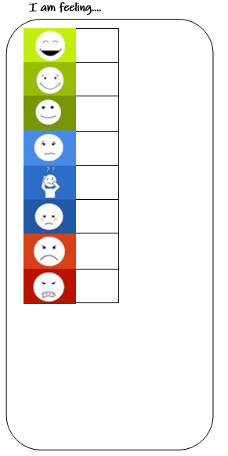
My experiences during lockdown -
The things I enjoyed.


My experiences during lockdown -
The things I didn’t like.
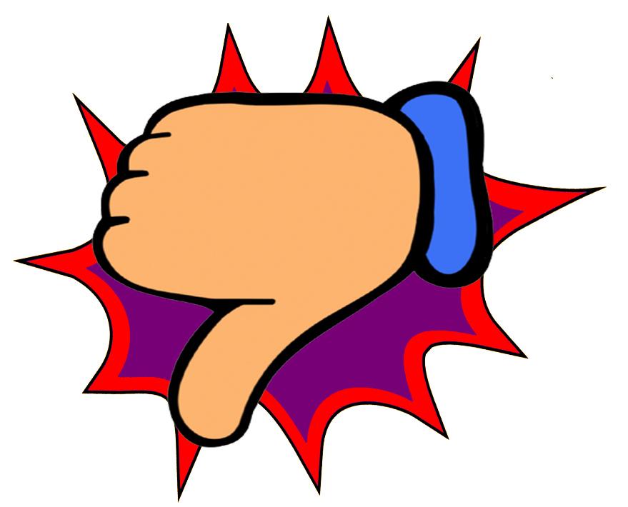


My feelings during lockdown.



My feelings during lockdown.



My feelings during lockdown.

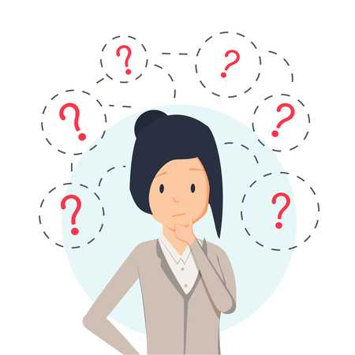
During the lockdown I felt overwhelmed. Whenever I would ask questions to my parents, they didn’t have any answers that made me feel better. This made me feel very unsafe because I didn’t know how long this would go on for. ___________________________________________________________________________________________________________________________________________________________________
My feelings during lockdown.

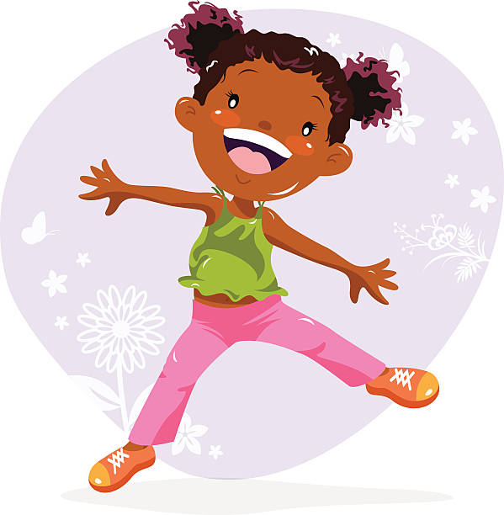
My feelings during lockdown.
During lockdown I got to spend lots of time with my mum and dad and brothers. We played inside loads because it wasn’t safe to be outside. We had lot of fun together and made up our own games, so we didn’t get bored.

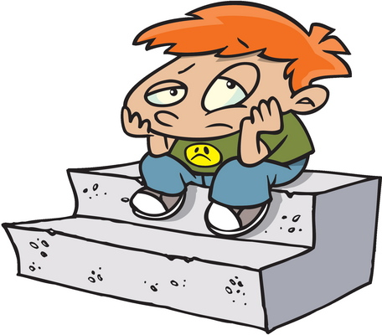
In the lockdown I felt really bored. I spent lots of time on my own and really missed playing with my friends. Sometimes I would see family members, but I wasn’t allowed to play with them, this made me feel very lonely and I felt upset for a lot of the time.
My feelings during lockdown.
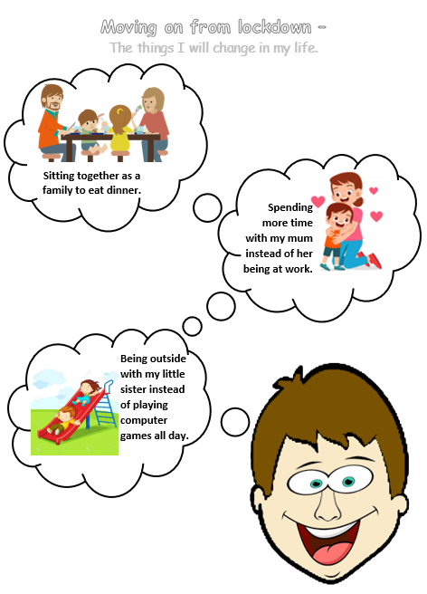

Moving on from lockdown –
The things I will change in my life.

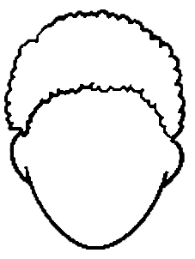

Moving on from lockdown –
The things I will change in my life.



Moving on from lockdown –
The things I will change in my life.

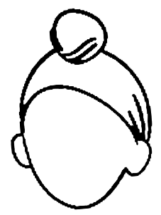
Moving on from lockdown –
The things I will change in my life.

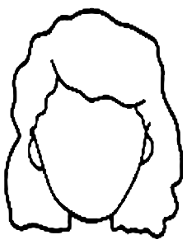

Moving on from lockdown –
The things I will change in my life.

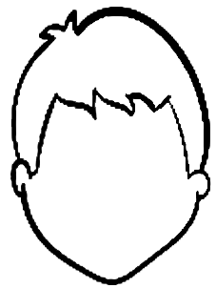

Moving on from lockdown –
The things I will change in my life.


