When we loose something we love.
Context:
This activity is designed to be used with primary children returning to school. It can be used to reflect on their experience of grief and loss. It can be adapted to be used with different ages.

Children and adults within the school community will all experience the loss of different things, experiences and people through this lockdown period. This will lead to them experiencing grief and this might be displayed in different ways.

Aim:
- To give children a space to reflect on things, experiences of people that they might have lost during this lockdown period.
- To have an awareness that grief might display itself in the form of different emotions.
- To know that grief can come in waves.

Introduction:
- Ask the children to think about things that have changed over the last few weeks. You might want to do this in different categories such as at home, at school or the people that they see. Or you may want to use the worksheets in ‘My Lockdown Experience as a starting point.
- Then think about a time that they lost something how did that make them feel? What did they do? They might find this easier to talk about in pairs initially.
- Then talk about during lockdown there are many different things that might have been lost and this can make us feel very different ways. Sometimes it can depend on how much we loved what we lost.
- Explain that we call the emotions we feel when we have lost something, grief.
- Have a look at the ‘Grief: Understanding the feelings behind it’ sheet. Ask the children to think about if they have ever felt any of these feelings when they have lost something.
- You could talk about how this might make them act and they could act out what that emotions makes them do and what they might look like when they feel that.

- Safety check – some of us might have had some really hard experiences or feelings during lockdown. No-one is going to be asked to talk about anything they don’t want to. If during this activity anyone feels they need to take a break, just give me a wave. If afterwards you would like to chat quietly with me or someone else about anything, just let me know.

Application:
Give the children the sheet below that asks them to think about change and loss in their own lives.
- Take time to talk with them about this and give those that want to share the opportunity to do this. If this happens ensure that the children accept all the different emotions that might be shared. Grief can look very different for different people.
- Explain to the children that sometimes the emotions that we feel can be very big emotions and feel very strong and sometimes they don’t feel as strong. We say that grief comes in waves.
- Show the children the sheet below explaining the grief wave.
- Ask the children to think about what they have shared that they have lost and ask them to put themselves where they think they are on the wave.

Relaxation:
Sometimes thinking about these things can be hard work and difficult. It might be that the children would appreciate having some time to relax afterwards. You might feel that either of these two mindfulness activities might help.
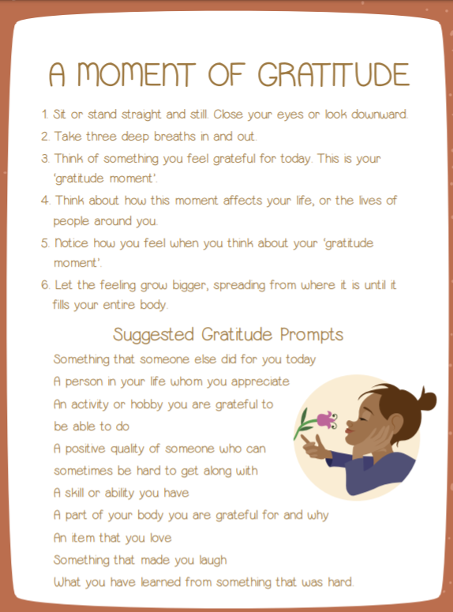
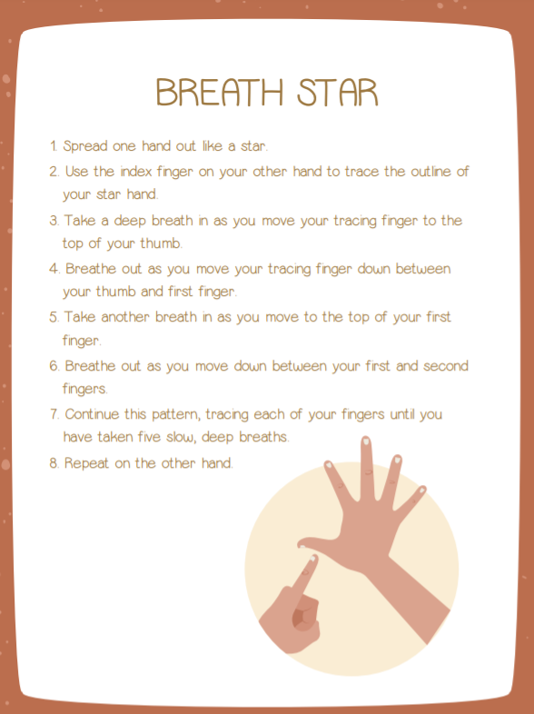

Ending:

Remind the children they can talk to you or another grown-up they trust about anything, no matter how big or small.

Extension:

There are some other books you might want to look at or use with particular children. If there are children who are finding things significantly difficult it is worth knowing what support is available to them and passing on your concerns to those that can refer them to get receive further support. Some of these books are available on Youtube, either as a PDF or a reading video.

The day the sea went out and never came back by Margot Sunderland
How are you feeling today? Molly Potter
No matter what By Debi Gliori
The Sad Book by Michael Rosen
Water Bugs and Dragonflies by Doris Stickney
The Invisible String by Patrice Karst
In My Heart By McKenzie Porter
Badgers Parting Gifts by Susan Varley

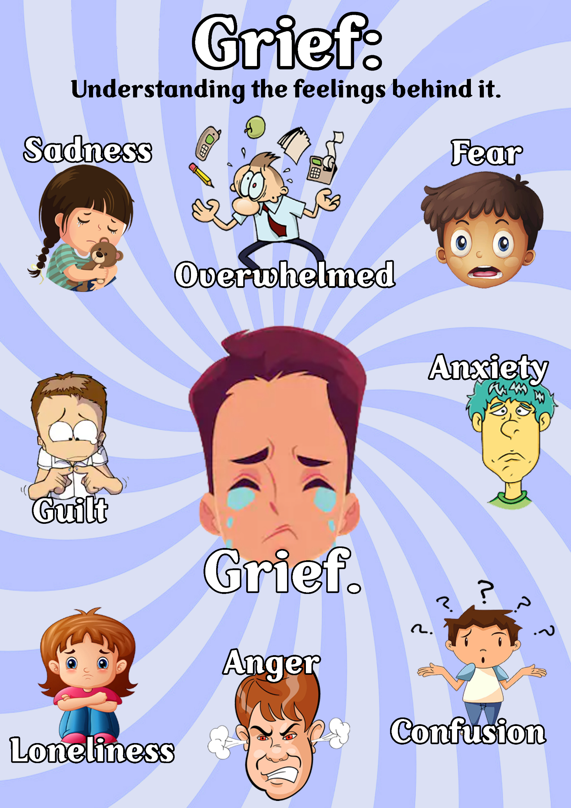
Think about something that has changed for you over the past few months,
or something/ someone that you have lost.
Draw or write your thoughts below, as you think about this change.

I am thinking about

How it used to be | How it is now | How I hope it will be in the future



