Anxiety Lesson
Context:
This lesson is designed for use with primary school children, as they return to school. It is designed with key stage 2 in mind, but could be adapted for key stage one, with simpler language. Feel free to use and adapt these activities in any way that is helpful for the age and ability of your group.
Aim:
- Understand what anxiety is
- Be able to spot early warning signs in our own bodies
- Create our own strategies to help us relax if we feel anxious or worried
- Identify any children who may need more support

Introduction:
- Remind the children of the feelings thermometer or the rainbow of feelings lesson if you have previously used them.
- Today we will think about anxiety.
- Have a group discussion: what is anxiety? How is it different to worry? This discussion is about generating thoughts and ideas, not about getting the right answer.
- Explain about anxiety, using this definition, adapted from mentalhealth-uo.org:
We will think about it in two parts. Here’s part one:

Everyone feels anxious or worried at times, especially when faced with stressful events and changes to our lives, it’s a natural human response.

Let’s think about this in relation to life at the moment:
- What stressful events or changes have we experienced recently? Discuss as a group
- We have all experienced lots of changes to our normal lives over the past few months. There are new rules to follow and lots of things that we can’t do at the moment, like seeing our friends or hugging our grandma. You may also have lots of questions about coronavirus, which even grown-ups don’t know all the answers to at the moment.
- In the middle of all this, it is likely that we have all felt more worried or anxious at times and it may feel that it is going on for a long time. This is a natural reaction, which most people will be experiencing at the moment.
- Some of you, may not have felt worried or anxious at all and that is ok too.

However, some people may experience being worried or anxious a lot more than others, this could be anxiety.
So let’s think about part two of the definition:

Anxiety is a persistent feeling of worry, fear or nervousness. If these feelings of anxiety are strong, frequent or continuous, they may begin to affect our ability to carry out life as normal.
If this happens we may need to get some help. There are lots of people who can help us including our family, people at school and our GP or school nurse. If you think you may feel like this, talk to an adult that you trust about it.

Anxiety and the body:

Whatever our levels of worry or anxiety, our body has ways of letting us know what we are feeling.
- Look together at the sheet ‘Physical Symptoms of Anxiety’.
- Discuss the symptoms together. Which of these symptoms do you feel sometimes? Can you think of times when you may have felt like this? Maybe when you were meeting a new teacher for the first time, moving house, going on a roller coaster or doing a test at school.
- Have you felt like this recently at all?

Not everyone will experience all of these symptoms. Each of us will have slightly different reactions in our body. We can think of these as early warning signs, our body’s way of letting us know something feels wrong.

- On your own, think about how your body lets you know when you are feeling worried or anxious.
- Use the Early Warning Signs sheet below to draw or write what happens in your body when you feel worried or anxious.
- You could label which part of the body you feel it in, or use different colours to show how your body feels.

Ways to help:

Now that we know our early warning signs, we can help ourselves to become less anxious. If you notice these feelings in your body, you could do something that helps you to relax.
- Brainstorm some ideas as a group for ways to relax. (examples: read a favourite book, cuddle a soft toy, hug someone you love, talk to someone you trust, stroke a pet, colour, listen to some happy or relaxing music, ask someone to tell you a joke, close your eyes and remember a happy holiday, drink a warm drink, have a warm shower or bath, do something physical to tire out your body, pretend to be a wobbly jelly, breathe calmly and deeply, watch a funny programme).

Different things work for different people
- Use the individual worksheet to write or draw some ideas of what works for you.
- You could display these in the classroom to remind children during the day.
- Children could take home a copy of this and their early warning signs and explain them to their family, so that others can help them notice how they are feeling and find ways to help.

Relaxation:

These discussions may have bought up many feelings or memories for some children. Give them some time to relax before moving on. Either by letting them choose one of their ideas from their list, or by doing a group relaxation. Below are some you may like to use:

Extension:
The following books are good for exploring worry and anxiety further with your group. If you think any of the children show signs of needing further support for anxiety, speak to your pastoral or safeguarding lead.

Ruby’s Worry, by Tom Percival
Myg and Me, by Services for Education
Willy and the Wobbly House, by Margot Sunderland. There is also an accompanying guidebook: ‘Helping Children or are Anxious or Obsessional (separate purchase)
Tennie Weenie in a Too Big World, by Margot Sunderland. There is also an accompanying guidebook: ‘Helping Children with fear’ (separate purchase)

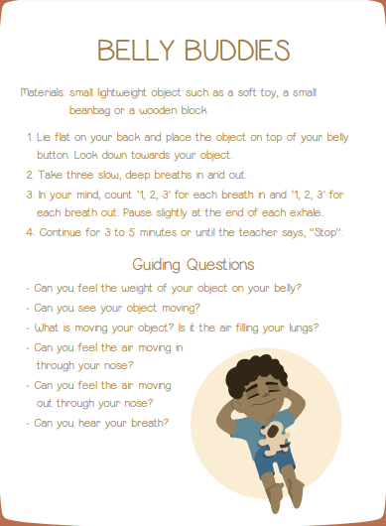
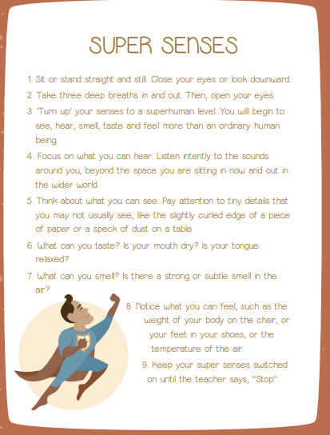

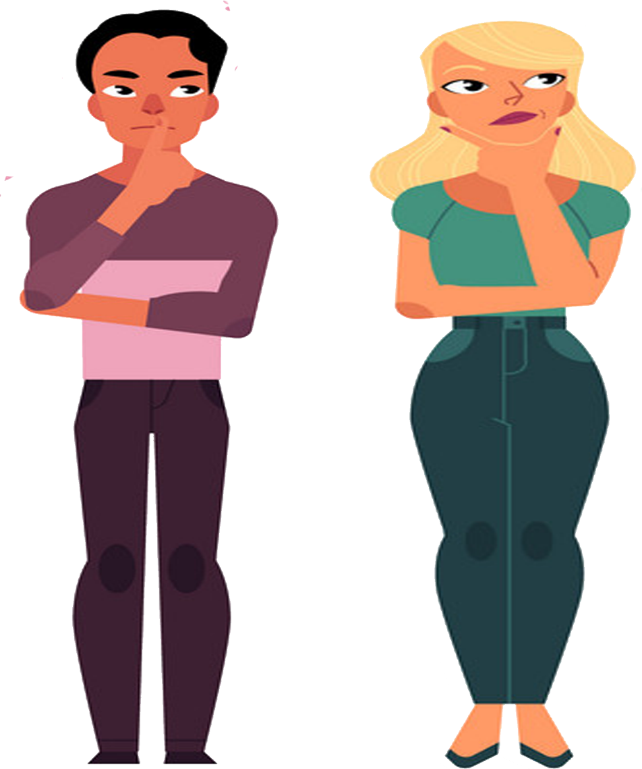
Physical symptoms of anxiety
Restlessness.
Aching muscles.
Unsettled, painful or knotted stomach.
Excessive sweating.
Headaches.
Dizziness.
Shortness of breath.
Sweaty or shaky palms.
Wobbly knees.
Flushed skin.
Dry mouth or throat.
Increased heart rate.
Frequent need for the toilet.
Lack of concentration.
Trouble sleeping.

Early warning signs - Knowing my body.
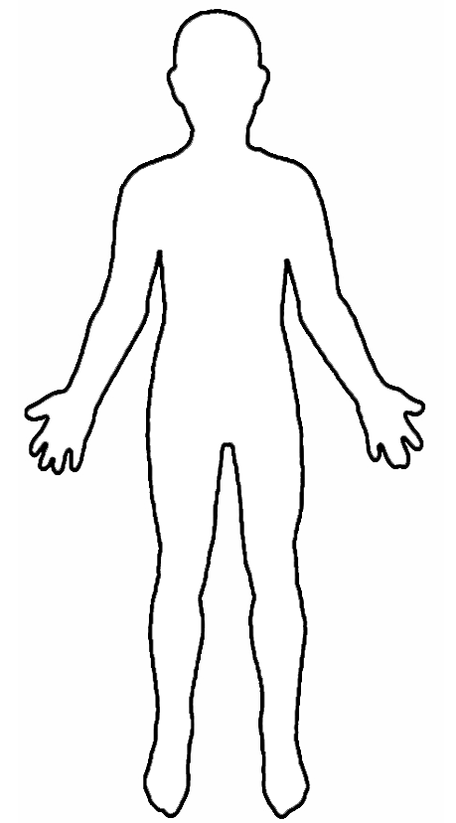

Things that help me relax.

