Year 3/4
Summer
1 & 2 2020
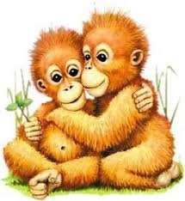
Welcome to the Jungle!

Maths
As amazing Rock Stars, we will continue to ‘Rock’ our Times Tables and we ask that your child continues to log on and ‘Rock out’ at home.


Purple Mash and Mathletics learning will be focused on measures, angles and time.

Use a watch, computer or smart device to learn to tell the time – it’s an important life skill not just a thing we do in maths.

Use these to practice angles.
https://www.visnos.com/demos/basic-angles
https://www.mathsisfun.com/geometry/protractor-using.html

Measures – help out with measuring ingredients for baking, pouring cold liquids into measuring jugs and counting amounts of money.
English
Fiction
Write your own story set in the Amazon rainforest – it could be about an explorer, a tribe or an animal. Use your storytelling skills to add action and dialogue before writing of typing it up. Don’t forget to use different sentence types and punctuation. Illustrate your short story and send it to us or record yourself reading it (think CBeebies bedtime story!)

Non-Fiction
Use websites to write a biography of Georgia O’Keefe or Sir David Attenborough. Alternatively, write your own ‘lockdown’ journal or letter to our Prime Minister telling him what you are missing about school (and enjoying about lockdown!)

Poetry
Choose either Rainforests or The Rainforest to learn, recite and perform (don’t forget to record and send to us on Purple Mash!)

Grammar, Punctuation & Spelling
We continue to learn spelling patterns. Descriptive language, fronted adverbials and correctly punctuating dialogue are some of the skills we will cover this term.



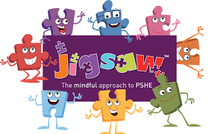

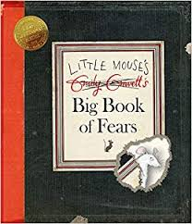
Topic work
Science – Our topic is Plants, Fruits and Seeds – please see websites for experiments and Purple Mash for activities.
Geography – Focusing on our beautiful rainforests – please see bingo board for activities and Purple Mash.
Computing – Remember to practice being safe on the internet and observe SMART rules.
PE – Try Joe Wicks workouts, Go Noodle, Fitness Blender kids and BBC Super Movers to keep you active!
Art & DT – Check out the work of Georgia O’Keeffe and Henri Rousseau – recreate their style in your own drawings and paintings.
French – Keep your French skills topped up using http://www.crickweb.co.uk/ks2french.html and https://www.bbc.co.uk/bitesize/subjects/z39d7ty
Music – Ask your smart speaker to play some rainforest sounds or look up on YouTube – listen to the animals, the rain, thunder, swish of the trees etc. Recreate the sounds and compose your own music to create a rainforest soundscape.

ICT
Children will explore the usefulness of the internet when researching topics. They will learn effective research techniques and how to quickly evaluate a site for reliability and usefulness. They will also learn how to create a PowerPoint presentation.

PHSE/Well-being & SRE
Watch Mrs Boughton on the Year 3/4 video as she guides you through mindful breathing. Practice The Superman: standing with the feet just wider than the hips, fists clenched, and arms reached out to the sky, stretching the body as tall as possible. The Wonder Woman: standing tall with legs wider than hip-width apart and hands or fists placed on the hips - take deep, even breaths and feel amazing and ready to take on the world!
Turn-on your “Spidey senses,” the super-focused senses of smell, sight, hearing, taste, and touch that Spiderman uses to keep tabs on the world around him. Pause and focus your attention on the present, be aware of the information your senses are bringing in.
Take part in Cosmic Kids Yoga on YouTube or practice some of the moves we do in class.



