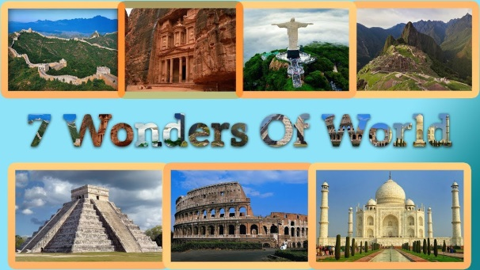  Make a model of one of the seven wonders of the world. | 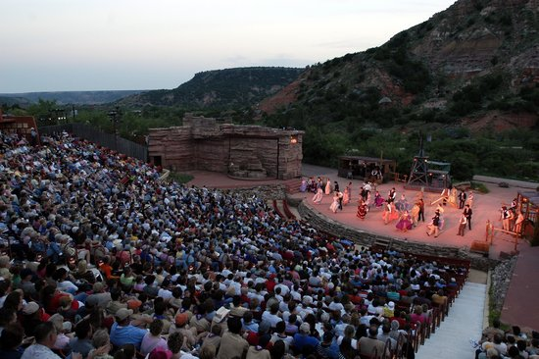  Write your own play that could be shown at the Coliseum in Rome.
Create a poster about your favourite animal.  Research and create an information poster or booklet on our favourite animal. You need to identify:  - The group which the animal belongs to.  - Where the animal lives.  - What the animal likes to eat and if it is an omnivore, carnivore or herbivore.  - The features that the animal has to help it survive.  - You could also include some other interesting facts about our animal.  - Is it found near any of the Wonders of the World? | 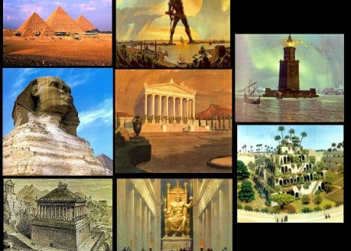  Create your own list of ‘Wonders of the World’ and explain why you think these man-made monuments are of artistic or architectural value that reflects and celebrates culture and social diversity
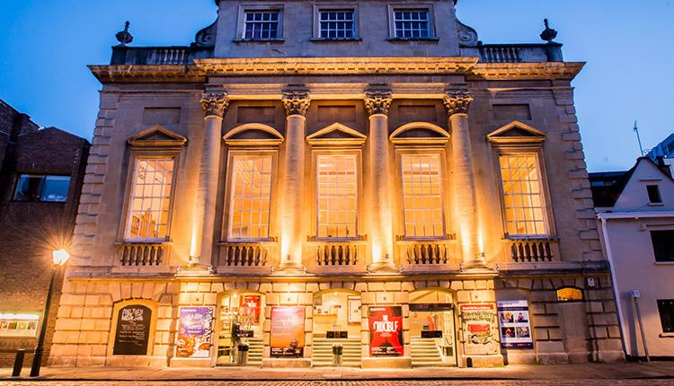  Create a piece of art work for a recognisable, man-made monument that you think is of artistic or architectural value. | Research Project (see back of sheet for more information) - Choose ONE of the types of wonders of the world; Ancient, Engineering, New, Natural or Industrial. Research these wonders and produce a piece of work that answers the following questions:  - How and when it was constructed  - What was / is its purpose?  - How long did it take to build?  - How much did it cost?  - It is still standing (if a building / structure)  - Is it still operational?  - How many people visit it?  - How is it looked after?  - Size

Research Project
This project will involve research and producing a piece of work that tells us:
- How and when it was constructed
- What was / is its purpose?
- How long did it take to build?
- How much did it cost?
- It is still standing (if a building / structure)
- Is it still operational?
- How many people visit it?
- How is it looked after?
- Size
You choose ONE of the following projects to research:
Choice 1 – The Seven Ancient Wonders of the World  - Great Pyramid at Giza  - Hanging Gardens of Babylon  - Statue Of Zeus at Olympia  - Temple Of Artemis at Ephesus  - Mausoleum of Maussollos at Halicarnassus  - Colossus of Rhodes  - Lighthouse of Alexandria | Choice 2 – Seven Wonders Of the Engineering World  - Channel Tunnel (UK / France)  - CN Tower (Toronto, Canada)  - Empire State Building (New York City, USA)  - Golden Gate Bridge (San Francisco, USA)  - Itaipu Dam (Brazil / Paraguay)  - Delta Works / Zuiderzee Works (Holland)  - Panama Canal (Panama)
Choice 3 – New Seven Wonders of the World  - Great Wall Of China (China)  - The Treasury of Petra (Jordan)  - Christ The Redeemer Statue (Rio, Brazil)  - Machu Picchu Inca Site (Peru)  - Chichen Itza Mayan Site (Mexico)  - Roman Colosseum (Rome, Italy)  - Taj Mahal (India) | Choice 4 – Seven Natural Wonders of the World  - Grand Canyon (USA)  - Great Barrier Reef (Australia)  - Harbour Of Rio De Janiero (Brazil)  - Mount Everest (China / Nepal)  - Aurora (Northern / Southern Lights)  - Paricutin Volcano (Mexico)  - Victoria Falls (Zambia / Zimbabwe)
Choice 5 – Seven Wonders Of the Industrial World
- SS Great Eastern (A ship designed by Brunel in the 1850s)
- Bell Rock Lighthouse (Scotland)
- Brooklyn Bridge (New York City, USA)
- London Sewerage System (UK)
- First Transcontinental Railroad (also known as the Pacific railroad) – USA
- Panama Canal (Panama)
- Hoover Dam (Arizona / Nevada - USA)

