Proposed Timetable for HAZEL class: 2020-21 (Week 2) All work will be uploaded to the school website. Challenges are available | Day 6 | Day 7 | Day 8 | Day 9 | Day 10
English:  Oak Academy  School Website  Purple Mash  Letter Join  BBC Bitesize | ENGLISH  Grammar, Punctuation and Spelling Questions – Think…Solve…Apply-style!  Answer the questions about grammar, punctuation and spelling. These questions are all based on things you have learnt so far in school this year. See whether you can still apply your understanding! The answers are available for you to self-mark it afterwards. | ENGLISH  Creating Characters  Create two characters – a hero and a villain.  Fancy an extra challenge? Write a short story (around two pages) featuring both of these characters. Try to use all of the writing skills we have learnt so far in English this year.  Have fun! | ENGLISH  Present Perfect and Simple Past Verb Tenses  Watch the video –  https://www.youtube.com/watch?v=Lwei4RQGapc  After that, complete the ‘Present Perfect and Simple Past Verb Tenses’  worksheet. | ENGLISH  Using Commas to Clarify Meaning  Watch the videos –  https://www.youtube.com/watch?v=mjv5Vp7tHsU  https://www.youtube.com/watch?v=gFvYY3frOXE  After that, complete the application activity to check you have understood. There are three difficulty levels to choose from and the answers to self-mark with | ENGLISH  Independent Writing Task – A First Visit  Write a recount of your first visit to a new place. Explain what happened and how you felt.  If you are stuck for ideas, you could talk about…  - The first time you came to the new school building on Plank Lane that we are in now!
Maths:  BBC Bitesize White Rose  School Website  Oak Academy  Purple Mash  Mathletics  NRich  Times Table Rock Stars | MATHS  What you have learnt so far this year – Think…Solve…Explain-style!  Answer the maths questions. These questions are all linked to what you have learnt in school since September. See whether your maths knowledge of these areas is still strong! The answers are available for you to self-mark it afterwards. | MATHS  Place Value Consolidation  Have a go at the ‘Place Value’ booklet.  There’s a range of questions to allow you to apply your learning to different question types. You can leave out any questions involving decimals/fractions.  However, if you fancy a challenge, complete those too! You can self-mark it afterwards to see how you did | MATHS  Counting and Place Value (Core Knowledge and Extension)  Core Knowledge is for everybody and Extension is available for those of you who would like a challenge afterwards  Complete the questions. Think really carefully and underline/highlight important parts of the question to help you. Self-mark your answers at the end to see how you did | MATHS  Rounding and Negative Numbers (Core Knowledge and Extension)  Core Knowledge is for everybody and Extension is available for those of you who would like a challenge afterwards  Complete the questions. Think really carefully and underline/highlight important parts of the question to help you. Self-mark your answers at the end to see how you did | MATHS  Roman Numerals and Number Problems (Core Knowledge and Extension)  Core Knowledge is for everybody and Extension is available for those of you who would like a challenge afterwards  Complete the questions. Think really carefully and underline/highlight important parts of the question to help you. Self-mark your answers at the end to see how you did
Reading:  Audio-books  Magazines  Purple Mash  Books | READING  Poetry Comprehension  Read the poem called ‘My Shadow’ by Robert Louis Stevenson. After you have read it multiple times to help you understand it more, answer the questions about it. You can choose your own level of difficulty – 1* is the easiest, 2* is of medium difficulty and 3* is the most challenging. The answers are available for you to self-mark afterwards. | READING  Improve Your Inference!  We have spent a lot of time talking about inference in school. Now it is time to put your skills to the test!  Complete the first two activities (Passage A and Passage B).  If you would like to develop your inferences further (extension activity), complete Passage c too! | READING  60 Second Read  Penguin Life Cycle   | READING  Anti-Bullying Reading Comprehension  Choose your own level of difficulty when reading and answering questions about Anti-Bullying Week 2020. | READING  Vocabulary task  (no worksheet)  Find out the meaning of the following words from our class novel ‘The Explorer’ and then write each one in an interesting sentence with correct punctuation:  - engraved  - absurd  - basking  - entangled  - unhygienic  - coax
Topic &  Other Activities  School Website Resources & Videos  BBC Bitesize  Oak Academy | TOPIC & OTHER ACTIVITIES  Science-The Solar System  Watch the following video about ‘The Solar System’.  https://www.youtube.com/watch?v=Qd6nLM2QlWw  Afterwards, complete the activity about The Solar System – you can choose your own difficulty level again, just like you did in reading.  In addition… (optional extra)  Explore the CBBC Newsround website. Read some articles, watch some video clips and answer some quizzes. | TOPIC & OTHER ACTIVITIES  PSHE–Road Safety  Watch the video that Mr Lewis mentioned on last week’s newsletter  https://www.youtube.com/watch?v=fIxnCv6S98Y  Can you complete the crossword using your road safety knowledge?  Art (optional extra for today)  Use the online tutorial (Draw with Rob) to help you draw a ‘Peacock!’  https://www.youtube.com/watch?v=Mu_h8rNxgn4 | TOPIC & OTHER ACTIVITIES  History-World History  Create a timeline to show the order of World History. Use the posters to help you. You can display the timeline any way you like.  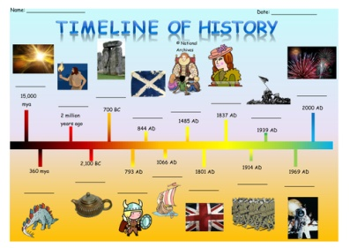  There are some blank timeline sheets you can use.  Optional extra: Prepare your School Councillor speech to read aloud when we return to school (only if you would like to be Hazel Class’ School Councillor! | TOPIC & OTHER ACTIVITIES  Science-Solar & Lunar Eclipses  Complete the full lesson on National Oak Academy about the Sun, the Earth and the Moon. In this lesson, you will also learn about satellites, including natural and artificial satellites. You will find out about the lunar phases and finally you will learn about solar and lunar eclipses.  https://classroom.thenational.academy/lessons/what-are-solar-and-lunar-eclipses-6nh3et  Optional extra:  Choose 20 words from the Y5&6 Statutory Spelling sheet that you find difficult to spell. Practise these in any way you wish! | TOPIC & OTHER ACTIVITIES  Languages  It is time to practise your French conversational skills!  Use the phrases to construct conversations for the characters in the comic strips, then ask someone to act out the conversations with you.  There is a worksheet for this with a phrase bank to help you.  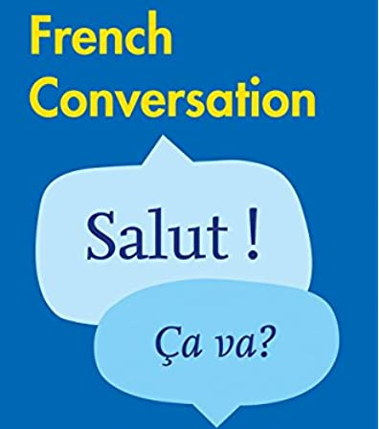  
PE  Sport  Physical Exercise | PE/SPORT  How to Learn Karate at Home  https://www.youtube.com/watch?v=BcP9AMeeJmg | PE/SPORT  7 Exercises for Kids to Get Stronger!  https://www.youtube.com/watch?v=cQO2V65eK3M | PE/SPORT  Indoor Walking Workout  https://www.youtube.com/watch?v=X7OzRLb2aKY | PE/SPORT  Join the Challenge – Dance Workout for Kids  https://www.youtube.com/watch?v=8y6bIbr-Hn0 | PE/SPORT  Hiit for Kids  https://www.youtube.com/watch?v=hKRR7_igyLo
Storytime | STORYTIME  Reading for pleasure – stories read aloud by famous people  https://www.youtube.com/watch?v=B6SrbWwVKAs  Enjoy listening to ‘The Elves and the Shoemaker’ read aloud by Chrissy Metz! | STORYTIME  Reading for pleasure – stories read aloud by famous people  https://www.youtube.com/watch?v=BNGUnk8JeLE  Enjoy listening to ‘Sylvester and the Magic Pebble’ read aloud by Reid Scott! | STORYTIME  Reading for pleasure – stories read aloud by famous people  https://www.youtube.com/watch?v=VLRIvyWUzxs&list=PLm-TLlTdQtXf7YP-Q5pU6KH6bfyXRkEda&index=22  Stellaluna read by Pamela Reed | STORYTIME  Reading for pleasure – stories read aloud by famous people  https://www.youtube.com/watch?v=op9Bc7GWCuw&list=PLm-TLlTdQtXf7YP-Q5pU6KH6bfyXRkEda&index=1  The Hula-Hoopin' Queen read by Oprah Winfrey | STORYTIME  Reading for pleasure – stories read aloud by famous people  https://www.youtube.com/watch?v=QwCxW7Nx4Ec&list=PLm-TLlTdQtXf7YP-Q5pU6KH6bfyXRkEda&index=8  I Need My Monster read by Rita Moreno
Hello Hazel Class!
Well done! You have now completed your first week of home learning. I do hope you enjoyed it. It is different but you have all embraced it!
Here is your second home learning timetable containing the information you will need for Days 6-10 (Tues 17th – Mon 23rd November).
You can do your tasks in whichever order you like. You can dip in and out, pick other activities in place of the ones we have suggested, or use your own resources if you prefer. But for those of you who want to, you can follow this every day to the letter - just like when you are at school! It’s up to you and the adults at home who are helping you. I have also included lots of optional extras and the ‘Challenge Work’ folder on the website will be updated with more tricky tasks!
Once you have completed the home learning for each day, you could work on some of your Wonders of the World homework tasks that were set at the start of the Autumn Term. On the website alongside the home learning, there will be some activities based on the US Election to try too! Don’t forget about your school council speech if you would like to be considered for the role.
Feel free to send me your work so I can see how well you have done. I have really enjoyed seeing some of the work that has been completed so far.
Have a great week everyone! I hope to see you back at school on Tuesday 24th November as planned.
Miss Thompson

