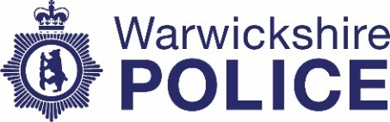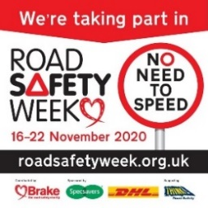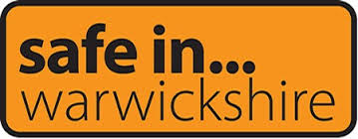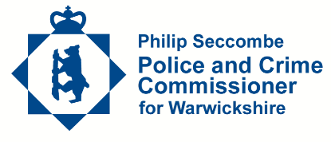
Competition Time
Your local police team are looking for budding artists to create some posters to tell people about dangerous parking next to our schools.
There will be prizes for winning entries at all of the schools and all schools who take part will receive a large banner to put on school gates or fences.
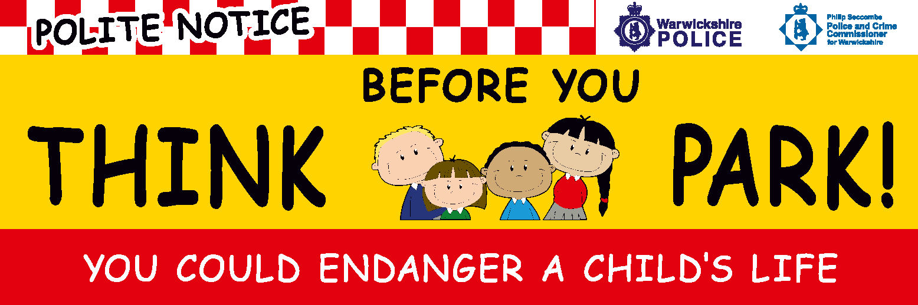
We hope you have some great ideas to promote Road Safety and Safer Parking to stop people parking on the pavements or Zigzag lines outside your school.
The winning entries will be turned into posters and put up on and around our local schools.
The closing date for entries will be Friday 8th January 2021 so you can get creative over the Christmas holiday. Put your name and the name of your school on the back of your picture.
Thank you and happy drawing!!

