Harrison is enjoying playing this game recommended by his school.

BBC Bitesize Games
Maths Challenge

If you like playing games and would like to improve your maths skills at the same time. BBC Bitesize have a game is called Guardians: Defenders of Mathematica. It says all you need is a pencil and paper and your brain to work your way through it!

Here's the link.
https://www.bbc.co.uk/games/embed/guardians-mathematica?exitGameUrl=https%3A%2F%2Fbbc.com%2Fbitesize%2Farticles%2Fzn2y7nb

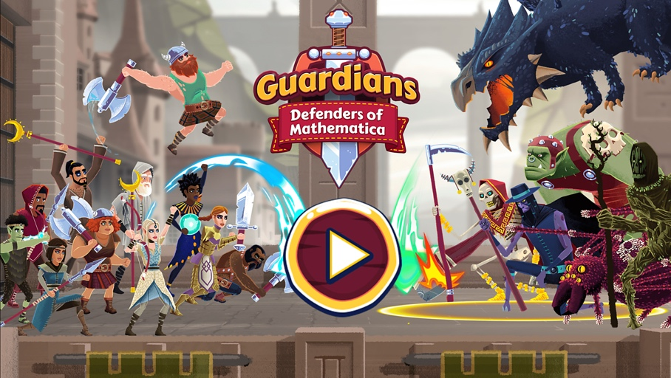

He also likes this one.

Science and Space
If you love anything to do with science, technology and space you will most likely enjoy visiting the Nasa Space Place page. You'll find lots of information and amazing facts, along with some fantastic photos.
Here's the link https://spaceplace.nasa.gov/

Learning through Landscapes – lots of outdoor activity free resources for children to have a go at.

Here's the link.
www.ltl.org/resources/tweet-treats/

I have attached the pdf for making a Tweet Treat!

