Guided Reading – Freddie Vs School 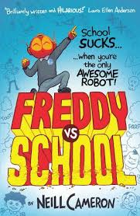

1 | Where does Freddie live?
2 | What did Freddie do to the staff room window at school?
3 | Which of Freddie’s parents has to come into school for meetings?
4 | What does Freddie believe he is?
5 | Who threw the ball?
6 (I) | What job could Freddie’s mum do?
7 | What three things are banned by the Code of Conduct?
8 | What featured in Freddie’s daydream?

 Guided Reading – Freddie Vs School
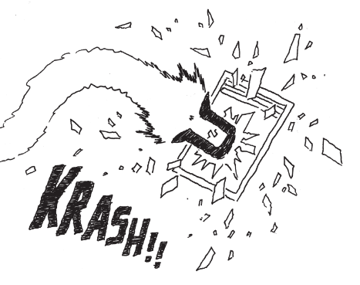
What do you think that Freddie was thinking as he flew through the staff room window?


