Tuesday Group 3
LO: Divide 2 digits by 1 digit
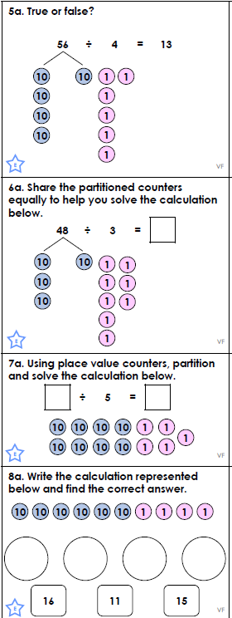
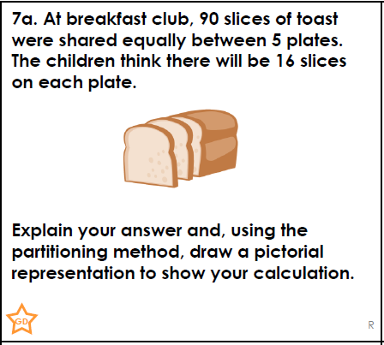
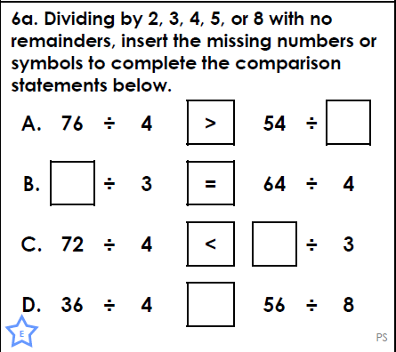

.  Think…Solve…Explain! | 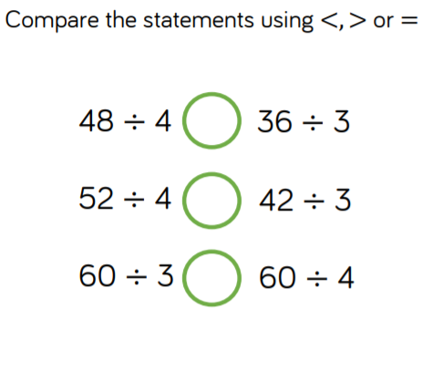  Use 3 and 4 times table facts to help you solve this.

