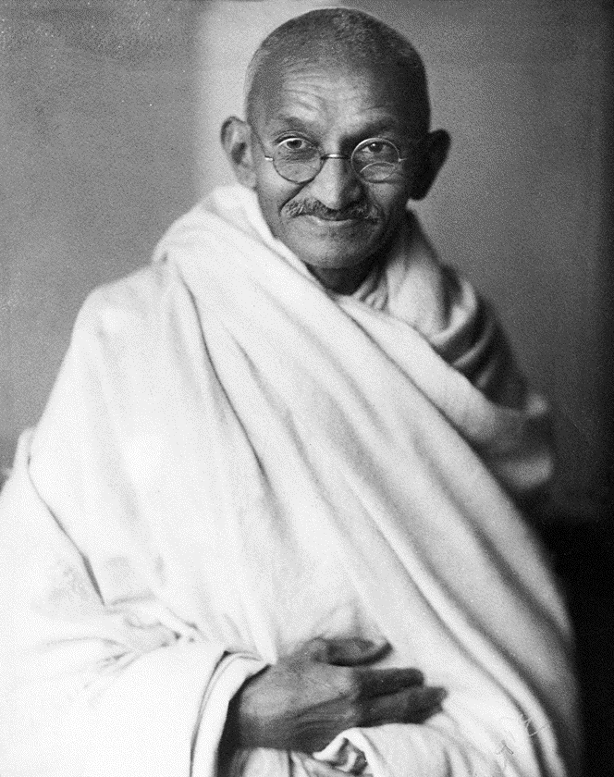


Why is Gandhi a Hindu hero?
What Hindu duties did Gandhi follow and how did he follow these?

Why is Gandhi a Hindu hero?
What Hindu duties did Gandhi follow and how did he follow these?

Why is Gandhi a Hindu hero?
What Hindu duties did Gandhi follow and how did he follow these?

