Yr 3 Guided Reading – The Boy who Sang with Dragons 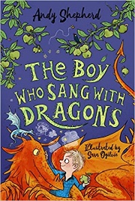
Parents: Please encourage your child to answer using the highlighted sentence support.
1 | What does Kat compare the cricket pitch to?  Kat compares the cricket pitch to …
2 | Where is ‘whack-a-mole’ played?  Whack-a-mole is played at…
3 | What did Liam fall over?  Liam fell over…
4 | What did Kai compare Liam to?  Kai compared Liam to…
5 | What is compared to a snot bubble?  A _______ is compared to a snot bubble.

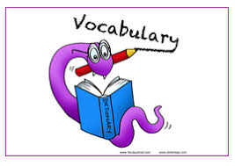 Yr 3 Guided Reading – The Boy who Sang with Dragons 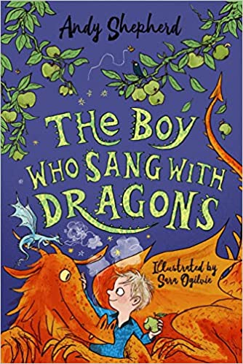
Use https://dictionary.cambridge.org/dictionary/english/ or https://kids.wordsmyth.net/we/
To find the meaning of these words
- Monstrosity
- Irate
- Squid
- Slalomed
- Illuminating

Write 3 sentences showcasing your new understanding of the words.
For Example: The new building was a monstrosity.

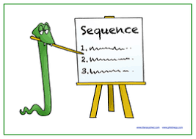 Yr 3 Guided Reading – The Boy who Sang with Dragons
Put these events in order:
Zing’s sky-blue scales flared brightly and the tip of his zigzag tail pulsed white as it flicked out. he flew up to the floodlight and illuminated the cricket pitch.

A super-stretched slime bubble is growing from the ground.

The children stand guard over the holes in the ground.

A splat of sticky goo landed on Liam’s head.

Liam stumbled over a heap of dirt.

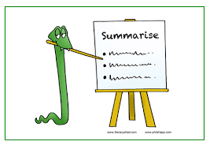 Yr 3 Guided Reading – The Boy who Sang with Dragons
Summarise the events that have happened in the book so far. What has happened to the children, dragons and cricket pitch?

