Week 2 Friday
Group 2
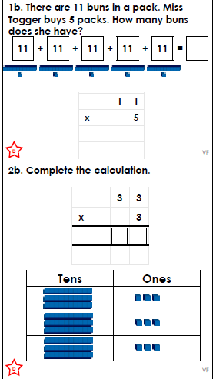
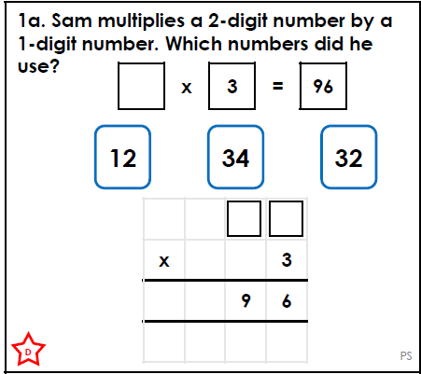

.  Think…Solve…Explain! | 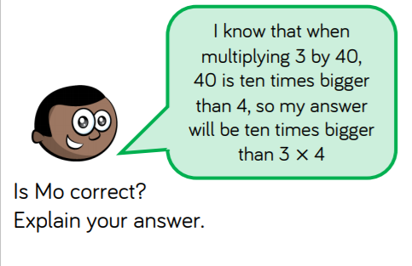

Answers
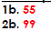

1a. 32

Think…Solve…Explain
Mo is correct 3 x 4 = 12. This helps Mo because he knows that 40 is 10 times bigger than 4. The answer will be ten times bigger so 3 x 40 - 120

