Online Learning – Week 2
Day 1 – Group 3
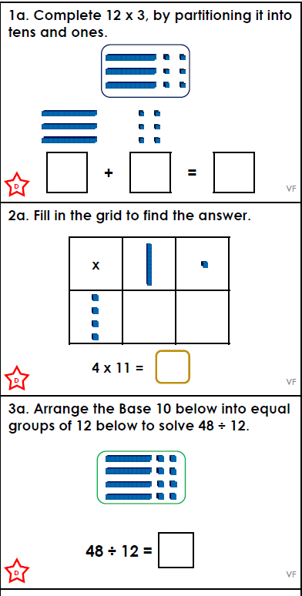
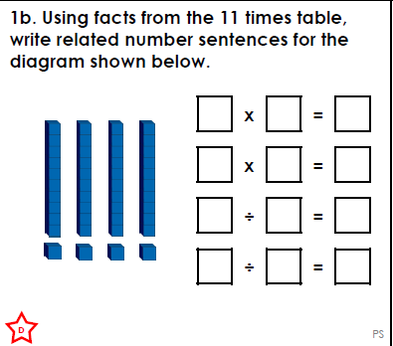

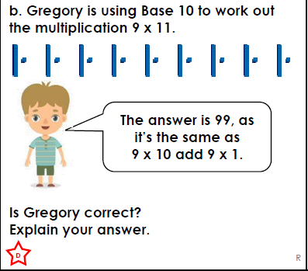

.  Think…Solve…Explain! | 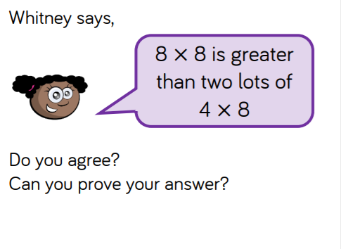

Answers
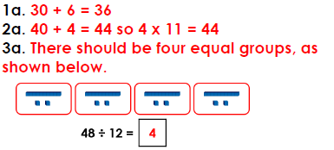
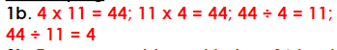
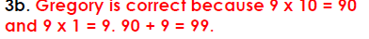

TSE
8 x 8 = 64
4 x 8 = 32 + 4 x 8 = 32 32 + 32 = 64
They are the same value

