Week 2 Thursday
Group 3
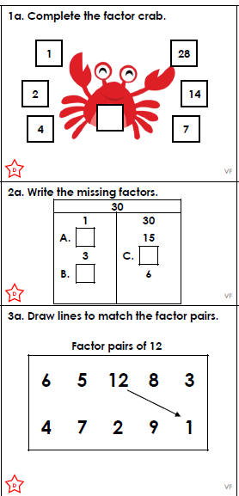
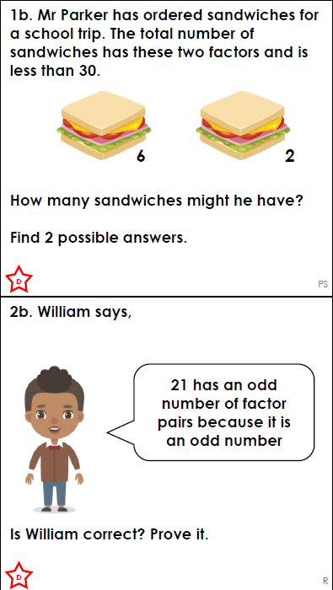

.  Think…Solve…Explain! | 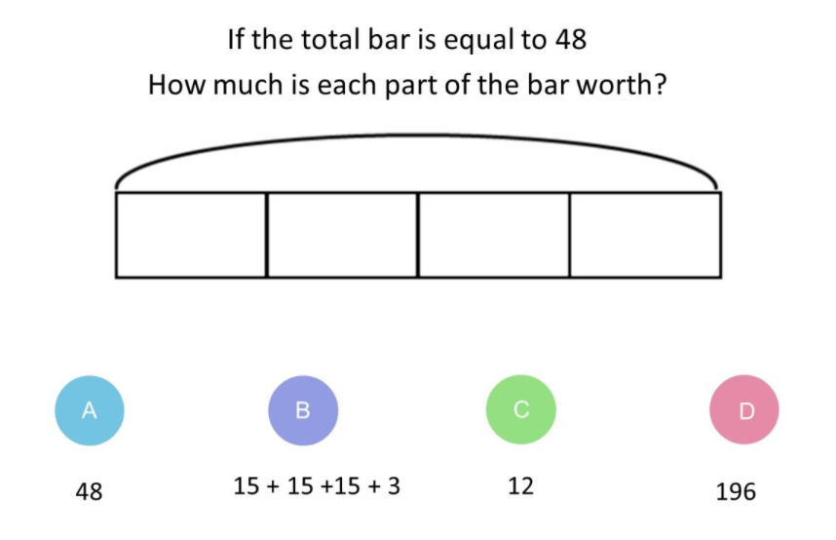

Answers
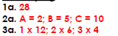

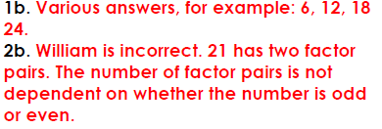

Think…Solve…Explain
Each part is worth 12 because 48 shared between 4 parts = 12.

