Online Learning – Week 2
Day 2 – Group 2
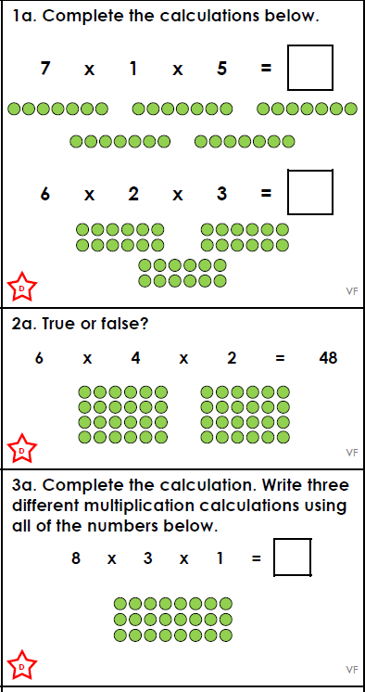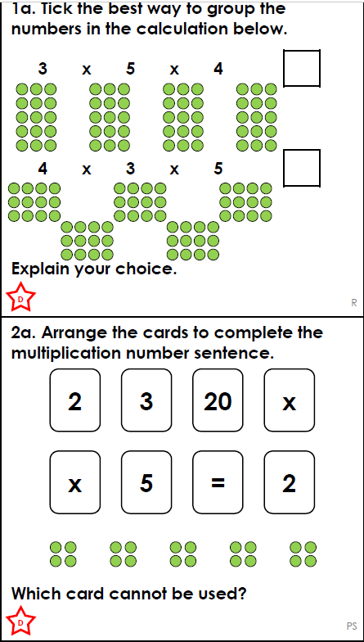
.  Think…Solve…Explain! | 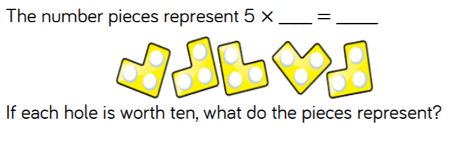

Answers
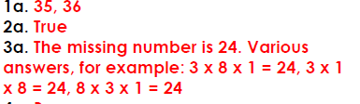
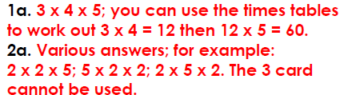

Think…Solve…Explain
Each piece has 3 holes so 3 x 10 = 30 The calculation is 5 x 30 = 150

