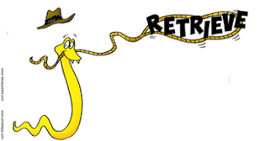Yr 4 Guided Reading – The Boy who Sang with Dragons 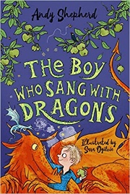
Parents: Please encourage your child to answer using the highlighted sentence support.
1 | Which two plants are dragons found in between?  The dragons are found between….
2 | Who does the garden belong to?  The garden belongs to…
3 | What colour is the dragon clinging to the boy’s back?  The ___________ coloured dragon is climbing on the boy’s back.
4 | What two jobs does the narrator say he has?  The narrator says he is a _____________ and a _______.
5 | What creature can squirt a litre of slime?  A _______ can squirt a litre of slime if it is scared.
6 | What were the golden dragons doing?  The golden dragons are …
7 | Whose hands were covered in fluff?  ______ hands were covered in fluff.
8 | Find and copy the simile Ted uses to describe the muddy mounds.

 Yr 4 Guided Reading – The Boy who Sang with Dragons 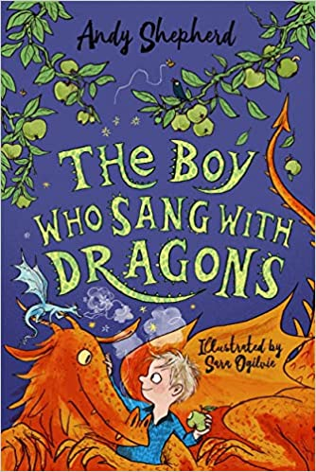
The children talk about the slime as a sign that the dragons are upset.
“Well, this dragon must be terrified,” Liam said, “We’re going to be wading through the stuff soon.”

- Predict why the dragons might be scared.
- What might be happening or about to happen?
- What do you think the story might be about and why?
- If I gave you this title to write your own story – what would you include in the story? Who are your characters? What would the big problem be and how would it get resolved?

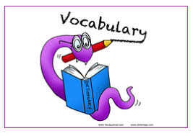 Yr 4 Guided Reading – The Boy who Sang with Dragons
turquoise |  | Small, pretty and delicate
constellation |  | Physical reaction when an organism defends itself
defence mechanism |  | Group of stars in the sky that is thought to look like, and is named after, an animal, object, or person.
wading |  | Blueish green colour
dainty |  | Walk in water or something else that makes movement slower or more difficult.
Match the above vocabulary from the text.
Use https://kids.wordsmyth.net/we/ to help.
Then, write your own sentences using the words correctly.
Example:
- The turquoise sea shimmered in the sunlight.
- The constellation of Orion shone brightly in the cold, velvety sky.
Find the definitions for rooted, clings, tilt, protruding and elaborate

