Week 4 Group 1 answers
Children name the different coins
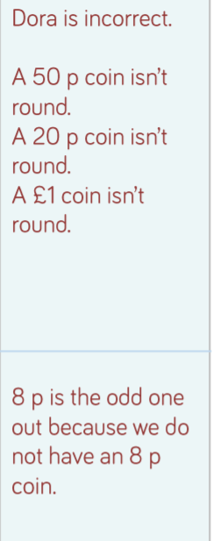
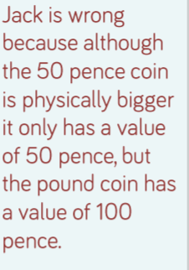

Tuesday
Three £5
Four £10
Four £20

£5/£10/£20

One £10 = Two £5
One £20 = two £10
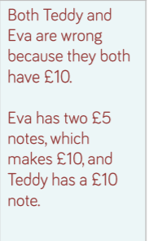
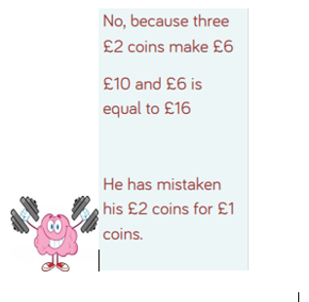

Wednesday
7p 14p 40p 30p 60p
> < <
34p 30p
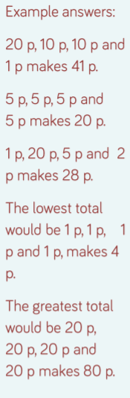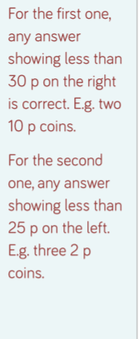
Thursday

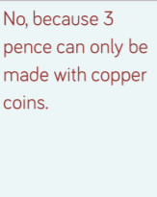

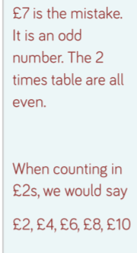
£7 £50 £15 £80
£20 3 x £10
£10 is odd one out because different coins rather than the same notes

Friday
£18.66
£12.52
£15.50 £22.22 (£5) £10.91



