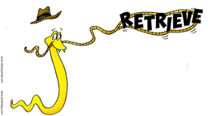 Yr 3 Guided Reading – 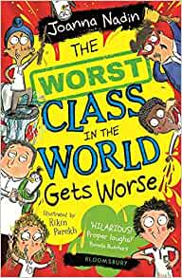
The Worst Class In The World Gets Worse
Parents: Please encourage your child to answer using the highlighted sentence support.
1 | Who makes a noise like a horse?  _______________ makes a noise like a horse.
2 | Which class is ‘literally the worst class in the world’?  The worst class in the world is ____________.
3 | What is the name of the boy who will be the first to walk a tightrope in space?  _________________ is the name of the boy who will walk a tightrope in space.
4 | Who was sick on Mr Nidgett’s shoes?  ________________ was sick on Mr Nidgett’s shoes.
5 | Who got nits?  ________ got nits.
6 | Who is 4A’s class captain?  _____________ is 4A’s class captain.

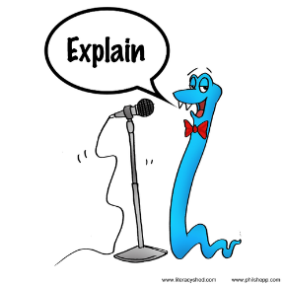 Yr 3 Guided Reading –
The Worst Class In The World Gets Worse
Grandpa says being arrested would be getting off lightly and IN HIS DAY he had to walk five miles to school barefoot and eat gravel for lunch.
- Is this likely to be true?
- Why did Grandpa say it?
- Explain what he is trying to prove to people.

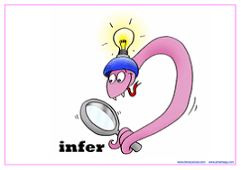 Yr 3 Guided Reading –
The Worst Class In The World Gets Worse
LITERALLY means actually scientifically TRUE. Mrs Bottomley Blunt pointed that out when Manjit Morris (who is my best friend, and who is going to be the First Human Boy to Walk a Tightrope in Space) said his head had LITERALLY exploded when he got a dog called Killer for his birthday, and it actually hadn’t.
Q) What does this tell us about how Manjit felt when he received a dog for his birthday? Explain how you could tell from what had been written. Think about how you would feel.

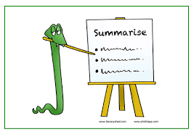 Yr 3 Guided Reading –
The Worst Class In The World Gets Worse
Tell someone what information you have found out in this chapter. Write down 4-5 key facts.

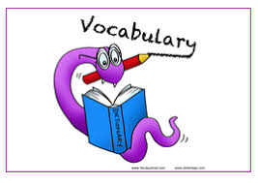 Yr 3 Guided Reading –
The Worst Class In The World Gets Worse

Find these words in the text. Read around the words. What do you think they mean?
- Write your own definitions.
- Look up the definition using the online dictionary
Use https://dictionary.cambridge.org/dictionary/english/ or https://kids.wordsmyth.net/we/
- Write the correct definition.
Smuggled
Sarcophagus
Gravel
Bollards
Fool-proof
Extraordinary

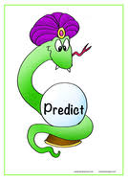 Yr 3 Guided Reading –
The Worst Class In The World Gets Worse
What sort of things might 4B do to ensure that they stay the ‘Worst class in the world’. Draw your ideas in the boxes and EXPLAIN what is happening (you will need another sheet so number your pictures).

