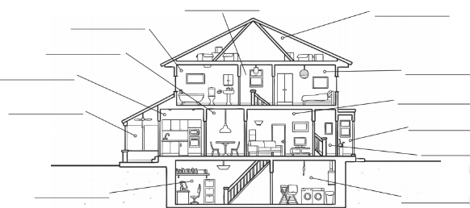
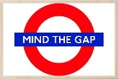

Draw an image of your home and label it in French.

