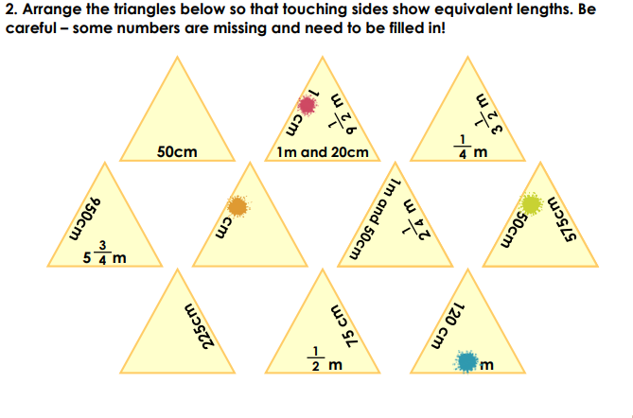
Challenge- Explain the steps you would take.
You could cut out the triangle to try and arrange the correctly.

Answer


