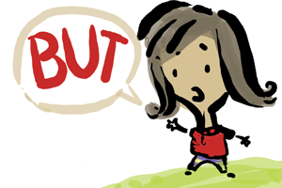

Read ‘School tomorrow- excuses for Mum’.
What do you notice/recognise?
Structure?
Devices? – Use the poetry toolbox poster to help you identify if there are any.
Likes- Why?
Dislikes- Why?
Patterns?
Punctuation?

