Year 3 & 4 Spring Homework
GO WITH THE FLOW
Performance  Using the instrumental music version of your favourite song – make up your own words to a song about the river. Email (1)   | Bake  Create a fishy ‘Cook Book’ including at least 5 recipes with pictures, ingredients and instructions. Cook a recipe and film it – Greatest British Bake Off style! Email (2)  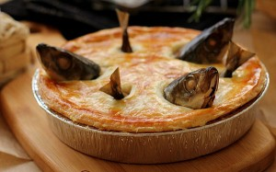 | Innovate  Design a costume for a dancer performing in a river themed dance. Collect fabrics you would use and present on a design board – you could make part of your design. Email (3)  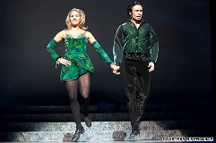 | Purple Mash  Choose a picture and match it to a description of a river feature.  Example on the website.  
Purple Mash  Can you find the missing words in the Water Cycle activity? Show off your geography knowledge in the physical features quiz.  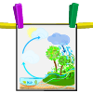 | Make  Bake and decorate some river-themed cupcakes or biscuits. Think about how you will decorate them. Eat them and evaluate how they look and taste. Email (4)  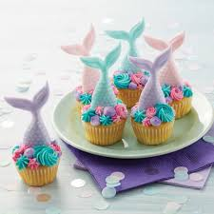 | Performance  Write a song, poem or rap about wasting water. Persuade people to be more careful with their water usage. Dress up and perform to camera. Email (5)   | Data  Find out about the UK’s top 5 longest rivers OR the top 5 longest rivers in the world. Draw a bar graph to show your results. Email (6)  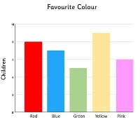
Explore  Research the plants and creatures that live on or near to the river bank. Using your knowledge from our habitats learning – create food chains and webs. Use arrows to show the flow of energy. Email (7)  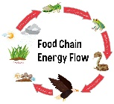 | Create  Create a sculpture of a river creature or plant. You could use clay, salt dough, papier mache, junk modelling or any material of your choice. Make a plaque with details of the artist, date and name of the piece. Email (8)  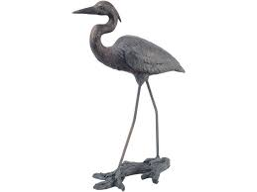 | Purple Mash  Describe the features of a river from source to sea.  Example on the website.   | Make  Make a model of a famous bridge such as Tower Bridge (London), Brooklyn Bridge (New York) or Golden Gate (San Francisco). Choose materials carefully – how many toy cars can it hold? Email (8)  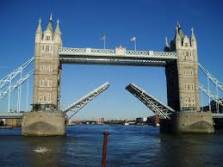
Make  Create a detailed collage or model of a waterfall or other river inspired feature using recyclable materials. Photograph and Email (9)  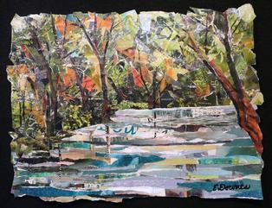 | Purple Mash  You are a water droplet on an exciting journey from the river to the sea. Write a postcard about your incredible journey.  Example on the website.   | Research  Find out key facts about the world’s top 10 rivers: length, number of countries it flows through, maximum width and depth etc. Make a set of Top Trump cards. Email (10)  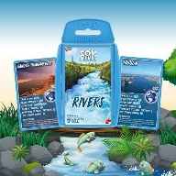 | Design  Illustrate and write and comic strip telling the story of how a drop of water enters the water cycle. Tell the story as it forms in the cloud and travels all the way to the sea to be evaporated again. Email (11)  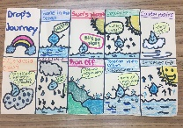
Design  Sailing boats are a popular sight on British lakes and rivers. Design some symmetrical designs for sailing boats sails.  Email (12)  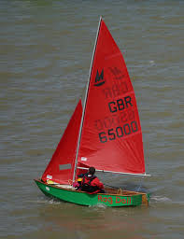 | Create  Research and create a PPT presentation about a famous river. You must include at least 5 facts, photographs and make it exciting for your audience! Email (13)   | Make  Design and make a rainwater gauge or weather station. Measure the rainfall for 3 weeks. Present your findings in a table or graph. Email (14)  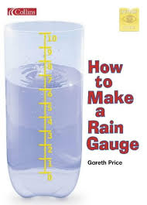 | Purple Mash  Mash cams & painting – put yourself in the place of a diver trawling the river or sea. Then paint a beautiful river reflection scene using paint tools.  Examples on the website.  

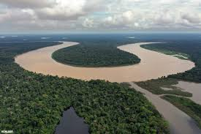 Links 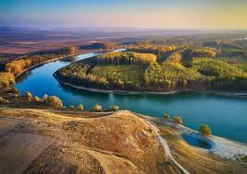
- A good starting point is something like this on YouTube https://www.youtube.com/watch?v=QcaTDX61BfE or most online streaming services will have instrumental versions. Record your performance and email into your teacher.

- Great British Bake Off theme https://www.youtube.com/watch?v=29QOIJPQdSc&list=RDQMJstsNcYAgEc&start_radio=1 A bit of Inspiration for your video from https://www.youtube.com/watch?v=9byjj9XzsVg Recipe inspiration https://www.bbcgoodfood.com/howto/guide/top-five-fish-recipes-kids

- Take some inspiration from the very first performance of Riverdance https://www.youtube.com/watch?v=w0v_pu6miJ8 and https://www.youtube.com/watch?v=HHNZuj6U8jo&list=RDw0v_pu6miJ8&index=5

- Lots of ideas and inspiration on Google and Pinterest.

- These might help to get you started https://www.youtube.com/watch?v=1IN1Uc-Ucl0 and https://www.youtube.com/watch?v=rl0YiZjTqpw

- You can draw your bar chart (scan or photograph to email) or create using a computer program. You may find this useful: http://www.top-ten-10.com/science/geography/rivers-uk.htm or http://www.primaryhomeworkhelp.co.uk/rivers/longest.htm

- Lots of ideas https://canalrivertrust.org.uk/media/library/41604.pdf

- Lots of ideas on Pinterest and Google. Use number 7 link again for inspiration. Give your sculpture a name!

- You may find this useful https://www.popularmechanics.com/technology/infrastructure/g2383/the-worlds-most-impressive-bridges/

- Lots of inspiration on Google and Pinterest

- Use links from number 6 or research your own.

- You may find this useful https://www.youtube.com/watch?v=y5gFI3pMvoI

- Lots of inspiration on Google

- You could use the links from number 6 as a starting point

- Lots of ideas on Google and Pinterest https://www.youtube.com/watch?v=BdeKdT0nwow and/or https://inventorsoftomorrow.com/2018/01/22/diy-weather-station-for-kids/
This homework bingo-board is designed to be completed over the course of the Spring term. Please make sure that your child chooses a minimum of 5 items from the bingo board they may do as many as they wish and extra work and effort will be rewarded. We kindly ask that no more than two Purple Mash activities are submitted – children are encouraged to use the tasks to develop their creative talents and reasoning skills.
Homework bingo is given out Monday 4th January 2021. Homework tasks are due by: Week beginning Monday 22nd March 2021, when your child will be given the opportunity to share their work with their class. Please speak to your child’s teacher if you have any questions about the activities.
As you can see we have included a number of suggestions for inspiration and ideas. However, we positively encourage your child to find and use their own ideas, website discoveries and recommendations from family and friends in order to help support them to complete their chosen activities.
Have fun with the activities and select ones that interest you. There are 10 weeks (not including half-term) to complete tasks. We look forward to celebrating your child’s creativity and will award merits and house points for effort as well as raffle tickets to win a small prize. The more tasks completed – the more chance of winning a prize! Good luck!
Activity Passport – in addition to the set tasks you may like to tick off some of the ideas on your child’s activity passport. These are activities which the government have stated each child should experience before leaving primary school. Choose from both Year 3 and 4 activities. Take a look – you’ll be surprised how many you will do already and give you inspiration for keeping children entertained during the holidays! Email photographs to the usual email addresses. Have fun!
As much as we love seeing your fantastic work we are asking you not to bring completed projects into school at this time. Instead, photographs and videos to showcase your fabulous efforts should be emailed to your teacher by an adult. This will be acknowledged with a ‘Thank you’ email and children will be given the opportunity to share their work with the class and answer questions about their project.
Please do not email work to the office.
Hawthorn (Mrs Gavan) plant.s@welearn365.com
Maple (Miss Mahmood) mahmood.a@welearn365.com
Oak (Miss Dolman) dolman.c@welearn365.com

Please ensure your email has your child’s name and the title of the piece of work
For example: Lexie Price – Tudor Dragon’s Den Fred Plant – Growing vegetables

We would like to take this opportunity to thank you for continuing to support your child’s learning.
Year 3 & 4 team

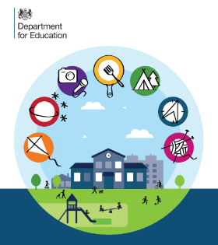
ACTIVITY PASSPORT

Year 3 Activities
Activities |  | Date
Compose a piece of music
Take part in a Roman banquet
Eat something you’ve not tried before
Create a mosaic
Design and make a board game
Climb a tree
Create a soundtrack for a piece of film
Make a pinhole camera
Make a musical instrument
Light a candle
Learn a new game
Make something out of wood
Cook outdoors
Learn to play a game of cards
Tell your class about your favourite character from a book
Produce rubbings of fossils
Try yoga
Eat something you have grown
Visit an art gallery
Stay away from home for a night

ACTIVITY PASSPORT

Year 4 Activities
Activities |  | Date
Make chocolate
Create a display for show and tell
Write and perform a poem
Perform in a play
Watch a play or a dance production
Use a camera to document a performance
Choreograph a dance
Make a sculpture
Create a sculpture trail
Explore inside a cave
Walk through a forest
Learn about a new religion and visit a new place of worship
Make up your own game and teach it to someone
Visit a museum
Skim stones
Visit a castle
Swim outside
Learn to sew on a button
Go hiking
Take part in a treasure hunt

