Spelling Bingo

  Write each of your spelling words 3 times each. | Have an adult give you a practice test.   | Write each of your words in fun letters.  E.g.: third | Write each of your words and another word that has the same beginning letter.  E.g.: shoes, shelf
  Have an adult scramble up your spelling words. You need to unscramble them! | 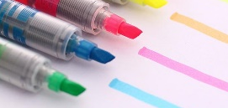  Use each of your words in a sentence. Highlight the spelling word in each sentence. | Write each of your words across and down.  E.g.: cake c ak e |   Write each word then trace the vowels in a different colour.
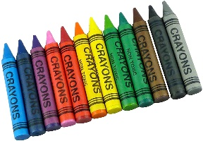  Write each of your words using crayons, markers or coloured pencils. | Write each of your spelling words 5 times each.   |   Use all of your spelling words in a poem. |   Pretend you are a cheerleader and cheer all of your words to an adult.
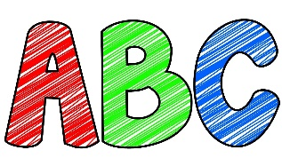  Write your words in alphabetical order. | Use your computer to type all of your spelling words. You can use fun colours and fonts! | Write each word 3 times in your best Letter-join. | Find the value of each of your spelling words.  Vowels=5 points Consonants=2 points  e.g.: apple = 16


