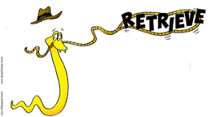Yr 4 Guided Reading – Hope Jones will NOT eat meat 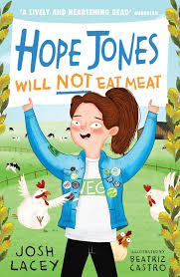
Parents: Please encourage your child to answer using the highlighted sentence support.
1 | How old is Hope Jones?  Hope Jones is …
2 | Who said, ‘You are never too small to make a difference.’  _______ said this.
3 | What is the date of the first blog?  The first blog is written on …
4 | Where was Finn going with his dad?  Finn was going to …
5 | What is a medjool?  A medjool is …
6 | Who was in Mitch’s shop?  _______ was in Mitch’s shop.
7 | What is the answer to the joke on the butcher’s board?  The answer to the joke is …
8 | What is the name of Becca’s boyfriend?  Becca’s boyfriend is called ...

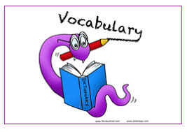 Yr 3 Guided Reading – Hope Jones will NOT eat meat
Use https:// https://www.wordhippo.com/
or https://kids.wordsmyth.net/we/
To find the meaning of these words
- Blog
- Wilderness
- Vital
- Protest
- Vegetarian
- Gambling
- Fundamental
- Boycotting

Write 3 sentences showcasing your new understanding of the words.
For Example: Hope Jones will not eat meat because she is a vegetarian.
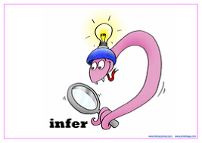 Yr 3 Guided Reading – Hope Jones will NOT eat meat
‘You are never too small to make a difference.’
- What do you think this means?
- Is your size important?
- What positive changes could you make to save the planet?
- What difference could you make?

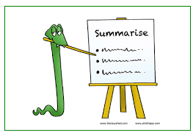 Yr 3 Guided Reading – Hope Jones will NOT eat meat
What has happened so far in the story?
What information do we know about Hope and her family?

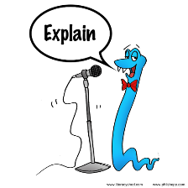 Yr 3 Guided Reading – Hope Jones will NOT eat meat
Why does Mitch put a sign outside of his shop – what is its purpose?

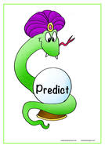 Yr 3 Guided Reading – Hope Jones will NOT eat meat
What do you think will happen next in the story?

