Lesson 1 -
  Think … Solve … Explain | 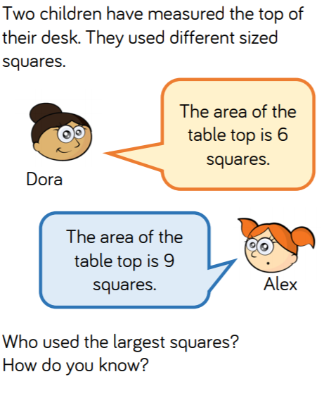

Lesson 2 –
Think … Solve … Explain | 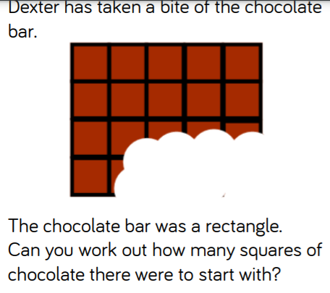

Lesson 3 –
Think … Solve … Explain | 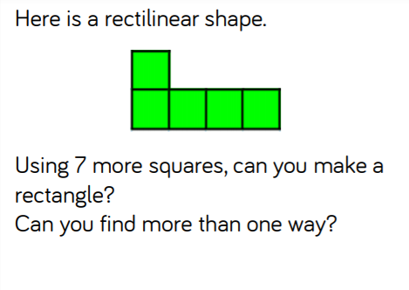

Lesson 4 –
Think … Solve … Explain | 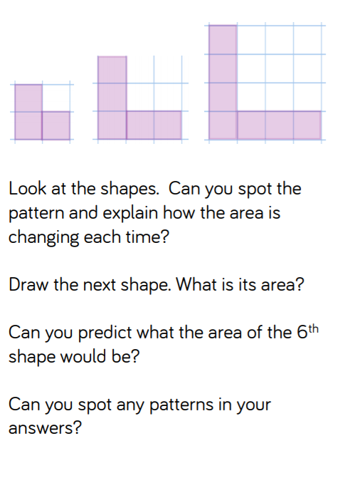

Lesson 5 –

Think … Solve … Explain

Answers
Lesson 1  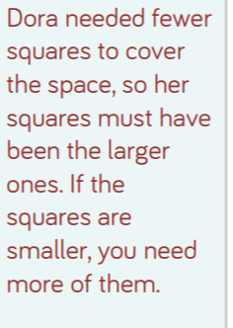 | Lesson 2  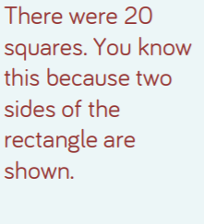
Lesson 3  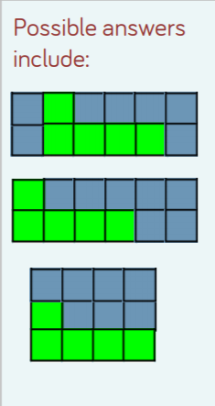 | Lesson 4  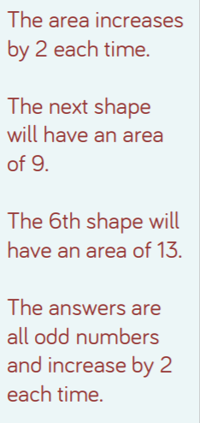
Lesson 5

