Where the Wild Things Are – Maurice Sendak

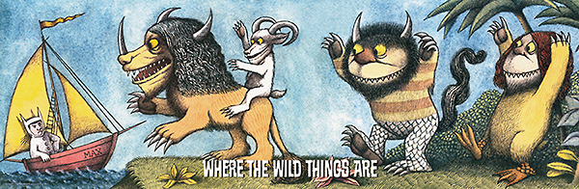

How many horns are on the Wild Things?

What colour is the smallest Wild Thing?

What is the boat’s name?

The Wild Things have yellow eyes. True or False

How many Wild Things have long hair?

There is a spotty Wild Thing. True or false

Now draw your own Wild Thing.

