The Seasons

In Great Britain we have four seasons: spring, summer, autumn and winter. Seasons note changes in the weather and hours of daylight because of the Earth’s changing position with the sun. Some countries do not have as many as four seasons and may just have two: wet and dry.
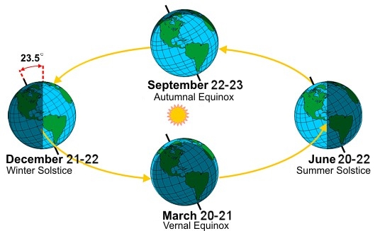

Spring:
The British springtime falls in March, April and May. It is a time for ‘new life’ where trees begin to blossom, plants start to flower and many wild animals have their young (like lambs and chicks).
The weather in the spring can be very unpredictable! Often it will rain but there can also be beautifully sunny days. The temperatures will begin to warm up although night times can still feel quite cold.
On the last Sunday in March, the clocks go forward by 1 hour (at 1am), and they go back again on the last Sunday in October (at 2am). This means that there will be longer days and more light in the evenings until the end of June.
During the springtime Easter will fall and there are two bank holidays.
Summer:
The British summertime falls in June, July and August. It is a time where the trees are full of lush green leaves, plants are at their prettiest in full bloom and wild animals are busy looking after their young, hunting and finding food.
Interestingly the weather in the summer is the hottest of the year. Generally there are long warm (hopefully sunny) days but it can rain and sometimes there can be thunderstorms. Even the night times are warm. Some years, Britain has also experienced heatwaves!
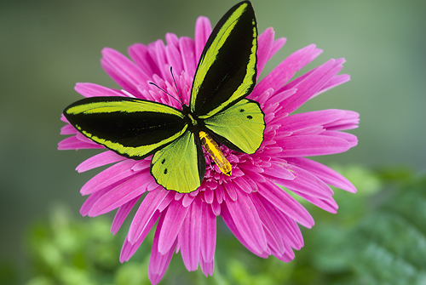
The longest day of the year occurs on 21st June every year. This means that there are the most hours of sunlight in the year on this day. Many children will often go to bed and it is still light outside.
In recent years (and for the foreseeable future) the festival of Eid has fallen in the summer months, sometimes twice!

Autumn:
In Britain autumn falls in September, October and November. It is a time where leaves change colour and begin to fall from the trees, plants start to die towards the middle and end of the season and wild animals prepare for the winter, storing food and building warm, safe nests or dens.
As with spring, the weather in the autumn can vary. Surprisingly, there can be very dry and mild conditions or it can be wet and windy for long periods. Often British people will experience both weather patterns within the same season! However the temperatures will begin to drop lower than that of the summer months.
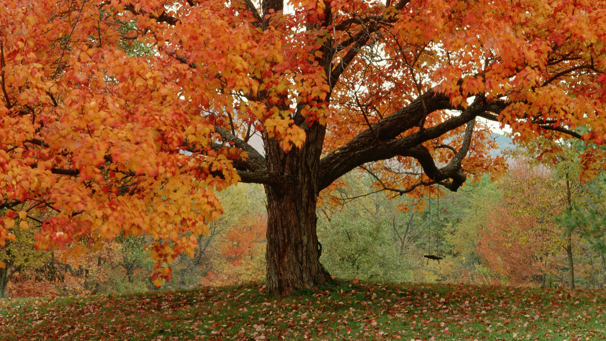
Hours of daylight will continue to decrease and evenings will seem much darker from the middle to end of the season.
The festival of Bonfire night takes place during the autumn to remember the failed attempt to blow up the Houses of Parliament, with King James 1, inside over 400 years ago. In the Jewish religion, the festival of Rosh Hashana (Jewish new year) is celebrated during the first two autumn months.

Winter:
The British winter covers the last month of the year and the first two months of the new year. It is the time where all the leaves have fallen from many of the trees, the summer plants have died back completely and many wild animals will be hibernating until spring.
Remarkably the weather in the winter is the coldest of the British year with freezing temperatures, icy conditions, frost and fog. Night time temperatures can often be below freezing (0 degrees celcius). Some years, Britain has also experienced heavy snow and blizzards!
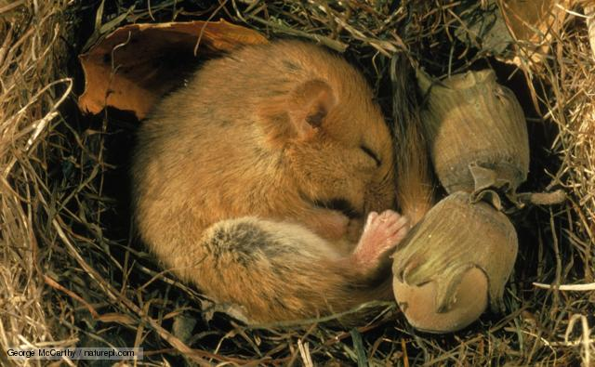
The shortest day of the year occurs on 21st December every year. This means that there are the least hours of sunlight in the year on this day and evenings will be darker earlier.
Christmas day and New Year (Chinese and European) are two of the many winter festivals that also includes Epiphany (twelfth day), the Birthday of the Sikh prophet Guru Gobind Singh and Shrove Tuesday followed by Ash Wednesday.

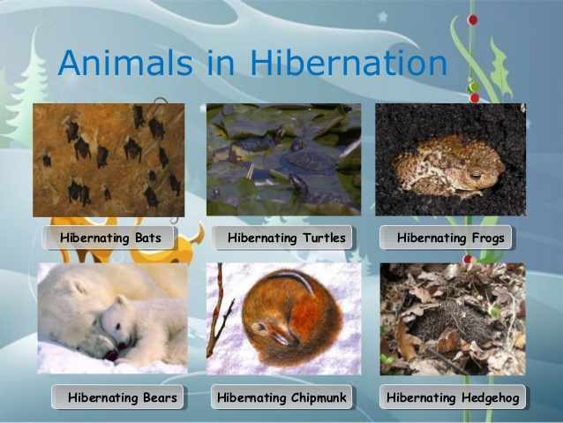

Learning about the seasons can be fascinating as there are so many changes that occur on the planet throughout the year. What have you learned about the different seasons and how Britain changes at different times of the year?
See how many of these features you can spot over the next few months…

