The Seasons

In Great Britain we have four seasons: spring, summer, autumn and winter. Seasons note changes in the weather and hours of daylight because of the Earth’s changing position with the sun.
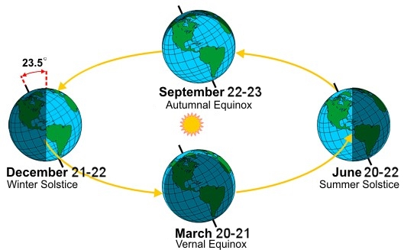

Spring:
The British springtime falls in March, April and May. It is a time for ‘new life’ where trees begin to blossom, plants start to grow and animals have their young.
Sometimes it will rain but there can also be sunny days in the spring. The temperatures will begin to warm up although night times can still feel quite cold.
We change the clocks in spring. This means that there will be longer days and more light in the evenings until the end of June.
During the springtime Easter will fall and there are two bank holidays.

Summer:
The British summertime falls in June, July and August. It is a time where the trees are full of green leaves, plants are at their prettiest in full bloom and wild animals are busy looking after their young, hunting and finding food.
Interestingly the weather in the summer is the hottest of the year. There are long, warm, sunny days but it can rain and sometimes there can be thunderstorms. Even the night times are warm. Some years, Britain has also experienced heatwaves!
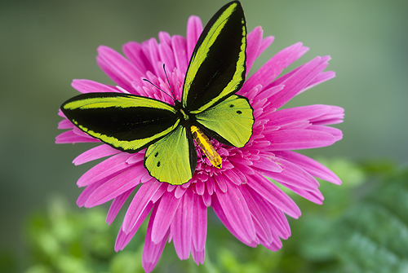
The longest day of the year is on 21st June every year. Many children will often go to bed and it is still light outside.
In recent years the festival of Eid has fallen in the summer months.

Autumn:
In Britain autumn falls in September, October and November. It is a time where leaves change colour and begin to fall from the trees, plants start to die and wild animals prepare for the winter, storing food and building warm, safe nests or dens.
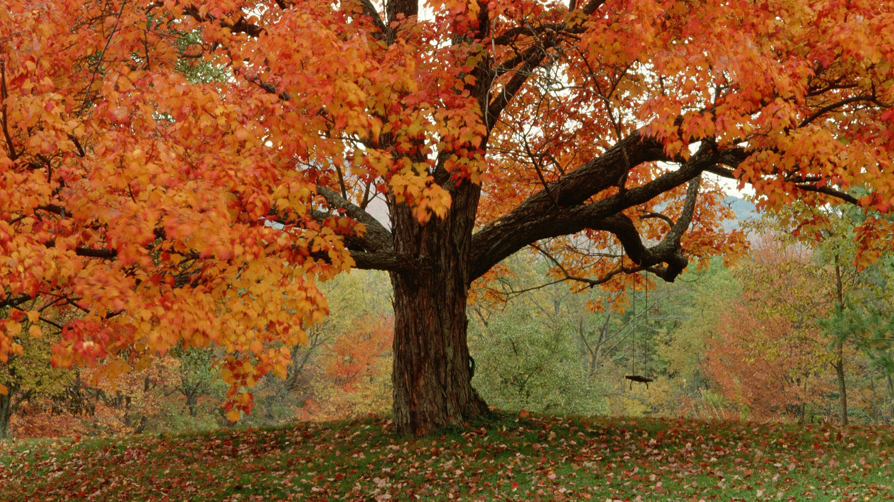
The weather in the autumn can be very dry and mild or it can be wet and windy. But the temperatures will begin to drop lower than that of the summer months.
There will be less light in the day and evenings will start to get darker. The clocks are also changed again.
Bonfire night takes place during the autumn and also Christians celebrate Harvest festival. In the Jewish religion Rosh Hashana (Jewish New Year) is celebrated during either September or October.
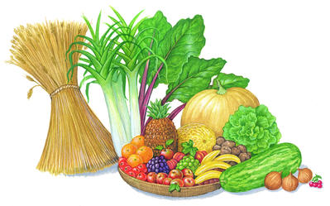

Winter:
Winter is December, January and February. It is the time where all the leaves have fallen from the trees, plants have died and many wild animals will be hibernating (sleeping) until spring.
The weather in the winter is the coldest of the British year with freezing temperatures, icy conditions, frost and fog. Britain will usually get some snow and sometimes it can be very heavy (blizzards)!
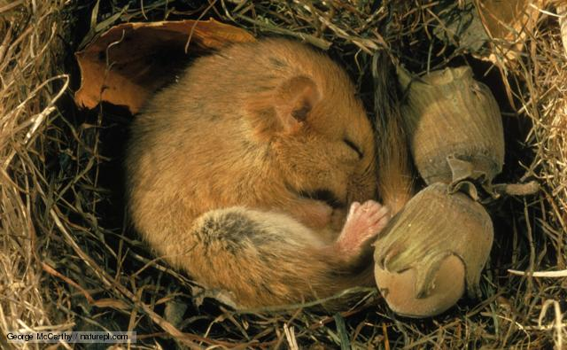
The shortest day of the year is 21st December.
Christmas day and New Year are two of the many winter festivals that also includes Epiphany (twelfth day), the Birthday of the Sikh prophet Guru Gobind Singh and Pancake day (Shrove Tuesday).

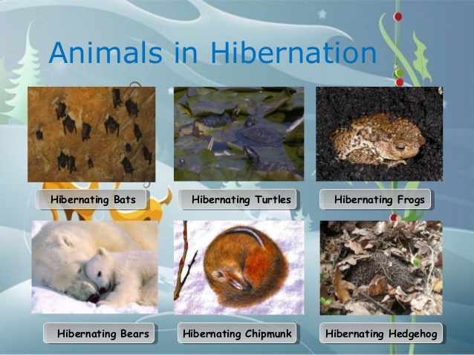

Learning about the seasons can be fascinating as there are so many changes that occur on the planet throughout the year. What have you learned about the different seasons and how Britain changes at different times of the year?
See how many of these features you can spot over the next few months…

