Retrieval & Inference
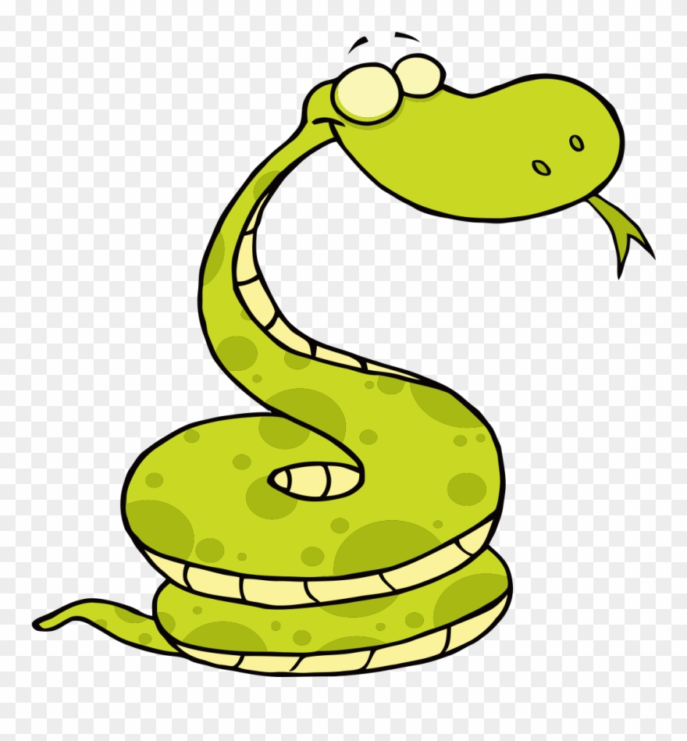
Name……………………………………………………………..

1. Which of these are British seasons? Circle two answers.
May autumn dry summer wet

2. Name 2 things that happen in the spring:
……………………………………………………………………………………………………….
...........................................................................................................................

3. When is the longest day of the year in Britain?
…………………………………………………………………………………………………………

4. In which season do the clocks go back one hour? Tick one.
spring ……….
summer ……….
autumn ……….
winter ……….

5. Which of these is not a winter festival currently? Circle your answer.
Epiphany Chinese New Year Ash Wednesday Eid

Retrieval & Vocabulary
Name……………………………………………………..

Find and copy a word that tells us that it is hard to guess what the weather will be like in the spring:
……………………………………………………………………

Using the text, name three animals that hibernate:
1…………………………………………………………………..
2…………………………………………………………………
3…………………………………………………………………

Retrieval & Vocabulary
Name……………………………………………………..

Match the correct fact to the correct season using lines:
Trees are full of green leaves Winter
Rosh Hashana is celebrated by Jews Spring
Lambs are born Autumn
Summer plants completely die Summer

Name the three winter months:
………………………………………………………………..
………………………………………………………………..
…………………………………………………………………

Inference & Retrieval
Name………………………………………………..

Describe, using the text, how you know that summer is a very ‘colourful’ time:
…………………………………………………………………………………………………………………………….
…………………………………………………………………………………………………………………………….
…………………………………………………………………………………………………………………………….
…………………………………………………………………………………………………………………………….

