Timetable for Rowan/Willow/Elm class. | Monday | Tuesday | Wednesday | Thursday | Friday
English:  Oak Academy  School Website  Purple Mash  Phonics Play  Letterjoin  BBC Bitesize | ENGLISH  Online live lesson  10:00 – 11:00  WHERE THE WILD THINGS ARE  Story and pictures by Maurice Sendak  Using various pictures of the Wild Things write sentences using impressive adjectives.  2A sentences - Include 2 adjectives before the noun.  Eg.  The hairy, green, wild thing roared.  The grotesque, purple, wild thing stood by the tall, green tree.  Phonics: Purple mash (2Do set)  Cloze activity – Use the sound to make the word.  - bl br cl cr | ENGLISH  WHERE THE WILD THINGS ARE  In the story Max’s emotions change. Describe how he feels at different points in the story.  Use the work sheet to describe his emotions.  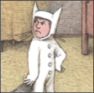  Phonics: Purple mash (2Do set)  Cloze activity – Use the sound to make the word.  - dr fl fr | ENGLISH  WHERE THE WILD THINGS ARE  Choose a Wild Thing to describe.  Remember to use capital letters and full stops when writing your sentences.  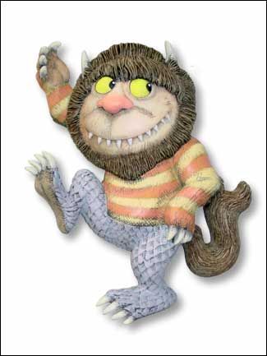  Phonics: Purple mash (2Do set)  Cloze activity – Use the sound to make the word.  - gl gr pl pr | ENGLISH  Online live lesson  10:00 – 11:00  WHERE THE WILD THINGS ARE  Use the illustration when Max reaches the island and he sees the wild things for the first time. Write questions he would like to ask them.  Use the openers:  Who?  What?  Where?  When?  Why?  You could hot seat with someone at home your answers. (Make a mask).  Phonics: Purple mash (2Do set)  Cloze activity – Use the sound to make the word.  - sc sk sm sn | ENGLISH  WHERE THE WILD THINGS ARE  Design and label your own Wild Thing.  When labelling your Wild Thing use some impressive adjectives.  Eg. sharp, yellow claws  round, beady eyes  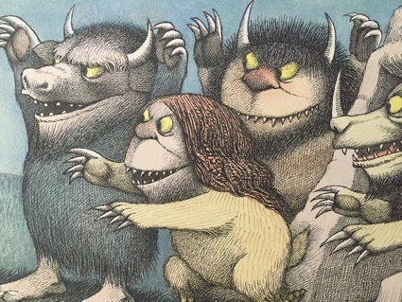  Phonics: Purple mash (2Do set)  Cloze activity – Use the sound to make the word.  - sp st sw tr tw
Maths:  BBC Bitesize White Rose  School Website work  Oak Academy  Purple Mash  Mathletics  NRich | MATHS  Online live lesson  1:30 – 2:00  Number: Counting in 3’s  Home booklet pg. 5  Challenge 1 question 1  Home booklet pg. 1&2  Rowan Class  Number: counting in tens.  Home booklet p3.  Challenge 1 &2. | MATHS  Online live lesson  10:00 – 11:00  Measures: length  Home booklet pg.8&9 | MATHS  Online live lesson  10:00 – 11:00  Measures: mass  Home booklet pg.10 & 11 | MATHS  www.thenational.academy  Year 1  Measures: (1): Length and Mass  Lesson 9  To find the mass of objects in units.  Year 2  Measures: length  Lesson 9  Applying knowledge of length when solving a word problem. | MATHS  www.thenational.academy  Year 1  Measures: (1): Length and Mass  Lesson 10  To experience standard units of mass (kg)  Year 2  Measures: length  Lesson 10  Consolidating and reviewing length.
Reading:  Books from home  Serial Mash  Books For Topics  Twinkl | Ned and the Jungle Animals  Chapter 1 (Purple Mash: Serial Mash: Diamonds)  Chapter One: Missing Words  (2Do set)  OR  Chapter 1: quiz  (2Do set) | Ned and the Jungle Animals  Chapter 2 (Purple Mash: Serial Mash: Diamonds)  Chapter Two: Joining Words  (2Do set)  OR  Chapter 2: quiz  (2Do set) | Ned and the Jungle Animals  Chapter 3 (Purple Mash: Serial Mash: Diamonds)  Drag – Make your own garden scene  (2Do set)  OR  Chapter 3: quiz  (2Do set) | Ned and the Jungle Animals  Chapter 4 (Purple Mash: Serial Mash: Diamonds)  Chapter Four: Carrot Picking  (2Do set)  OR  Chapter 4: quiz  (2Do set) | Ned and the Jungle Animals  Chapter 5 (Purple Mash: Serial Mash: Diamonds)  Sequencing – Can you remember the story?  (2Do set)  OR  Chapter 5: quiz  (2Do set)
Topic &  Other Activities  School Website Resources & Videos  BBC Bitesize  Oak Academy | RE  What makes some places sacred?  Where do you feel safe?  Why do you feel safe there?  Can you think of any spaces that are special to other people?  Look at a picture of a local church/mosque and synagogue. These places would be called sacred or holy.  Task: Draw your special place. | RE  What makes some places sacred?  Some people worship God in different ways and in different places.  www.thenational.academy  Key Stage 1 Judaism  Lesson 3  Where do Jews worship today?  Why is the synagogue important?  https://www.bbc.co.uk/teach/class-clips-video/religious-education-ks2-my-life-my-religion-prayer-in-islam/zjndxyc  The Mosque. (watch the clip).  What is a mosque like?  Task: Sort the key areas in the place of worship/artefacts. | Mindfulness  Online live lesson  1:30-2:00 | RE  What makes some places sacred?  Give reasons why places of worship are important in the community.  Task: Make a list for how a place of worship can help a local community. | Topic - weather  Online live lesson  10:00-11:00
PE  Sport  Physical Exercise | Music  www.thenational.academy  KS1 Music Pulse  Lesson 1 - Understanding pulse | Music  www.thenational.academy  KS1 Music Pulse  Lesson 2 - Creating simple patterns | Music  www.thenational.academy  KS1 Music Pulse  Lesson 3 – Understanding how sound is represented by symbols | Music  www.thenational.academy  KS1 Music Pulse  Lesson 4 - Physicalising pulse in different ways | Music  www.thenational.academy  KS1 Music Pulse  Lesson 5 - Maintaining pulse and finding the strong beats
Storytime | www.bbc.co.uk  Cbeebies – Jackanory Junior  Jackanory Junior – Fig’s Giant  Duration 14:08 | Design your own giant.  Write what you would play with your giant. | www.bbc.co.uk  Cbeebies – Jackanory Junior  Jackanory Junior - Explorer Trauma  Duration 14:07 | Design your own bush tucker biscuit to make your teacher’s cheeks turn red, white then green! | WHERE THE WILD THINGS ARE  Story and pictures by Maurice Sendak  Comprehension
Hello parents and children in Rowan, Willow and Elm.

Here are your weekly suggestions for Reading, Writing, Maths, Topic, PE and a story at the end of the day. You can do them in which ever order you like and, as has always been the case, we don’t expect you to be doing it all.
So you can dip in and out, pick other activities or use your own resources if you prefer. But for those of you who want to you can follow this every day to the letter!
Have a great week and stay safe!

Included are other Maths resources that link with the learning for this week.

