Cut and stick the different climates to their description.

Polar  Eg. Greenland  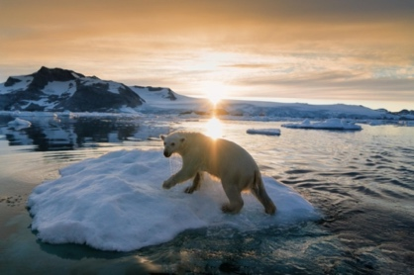 | - July and August are the warmest months.  - It rains throughout the year.
Arid  Eg. Egypt | - Clear, hot and dry weather.  - Some rain in spring and autumn.
Mediterranean  Eg. Spain | - Long winters.  - Temperature rarely above freezing.

Temperate  Eg. UK | - Lots of rain (almost every day).  - Hot all year.
Tropical  Eg. Brazil  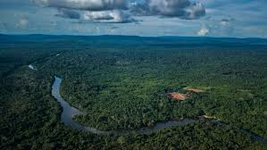 | - Very dry.  - Hardly any rain.

