L.O: Identify compound words
Summer:
The British summertime falls in June, July and August. It is a time where the trees are full of lush green leaves, plants are at their prettiest in full bloom and wild animals are busy looking after their young, hunting and finding food.
Interestingly the weather in the summer is the hottest of the year. Generally there are long warm (hopefully sunny) days but it can rain and sometimes there can be thunderstorms. Even the night times are warm. Some years, Britain has also experienced heatwaves!
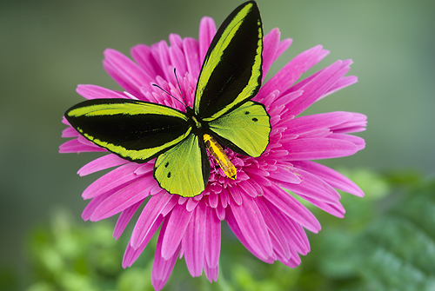
The longest day of the year occurs on 21st June every year. This means that there are the most hours of sunlight in the year on this day. Many children will often go to bed and it is still light outside.
In recent years (and for the foreseeable future) the festival of Eid has fallen in the summer months, sometimes twice!
A colourful butterfly.

Autumn:
In Britain autumn falls in September, October and November. It is a time where leaves change colour and begin to fall from the trees because plants start to die. Some animals prepare for winter by hibernating underground.
As with the springtime, the weather in the autumn can vary. Surprisingly, there can be very dry and mild conditions or it can be wet and windy for long periods. Often British people will experience both weather patterns within the same season! However the temperatures will begin to drop lower than that of the summer months.
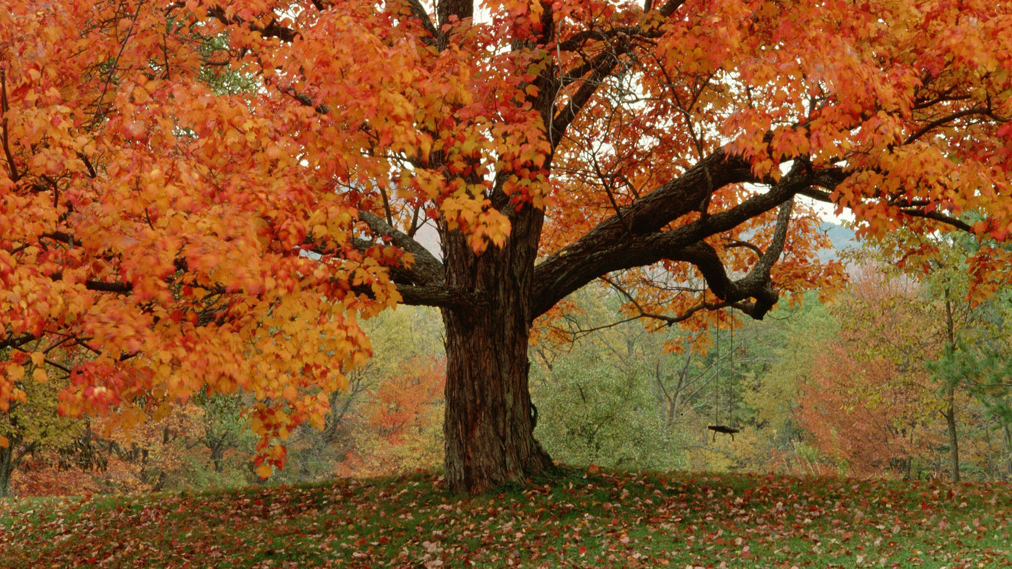
Hours of daylight will continue to decrease and evenings will seem much darker from the middle to end of the season.
Bonfires and fireworks are lit during the autumn to remember the failed attempt to blow up the Houses of Parliament, with King James 1, inside over 400 years ago. In the Jewish religion, the festival of Rosh Hashana (Jewish new year) is celebrated during the first two autumn months.

