Timetable for Elm class: Week 11 | Day 1 | Day 2 | Day 3 | Day 4 | Day 5
English:  Oak Academy  School Website  Purple Mash  Phonics Play  Letterjoin  BBC Bitesize | ENGLISH  The Egg by M P Roberston  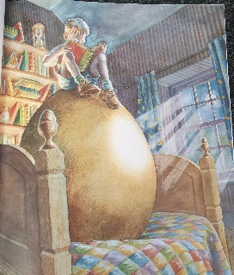  Look at page 4 and focus on the picture of George sitting on the egg in his bedroom. Write 3 sentences to explain what you think is happening in his bedroom.  Worksheet: The Egg Descriptions MONDAY | ENGLISH  The Egg by M P Roberston  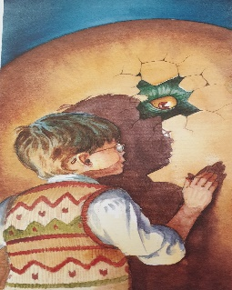  Write a description about what you think is going to emerge from the egg. What is the ‘emergence’ like? Describe it.  Resource: Descriptions of what might emerge from the egg TUESDAY (this shows two examples of how this could be written).  Worksheet: What Might emerge from the egg TUESDAY | ENGLISH  The Egg by M P Robertson  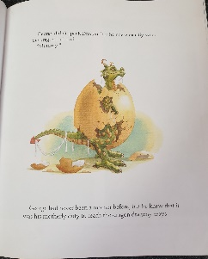  What could George teach the dragon?  Make a bullet point list of your ideas. Try to think of 5 things and write a sentence for each (for a challenge can you think of 8 things?)  Resource: WEDNESDAY What could George teach his dragon? | ENGLISH  The Egg by M P Robertson  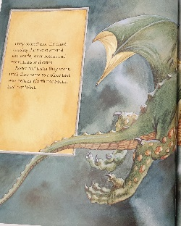  Look at the page ‘They soared into the night chasing the moon around the world...’ Write a paragraph to describe where they could go. Try and include a place name remembering a capital letter.  Worksheet: THURSDAY They soared into the night Worksheet | ENGLISH  Read the whole book: https://www.youtube.com/watch?v=aEyD_JX5x84  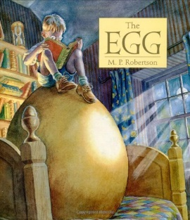  Compare the two dragon stories read this half term: The Dragon machine & The Egg. Complete the Venn diagram using the ideas on the sheet.  Worksheet: Dragon Machine & Egg Venn Diagram Comparison B FRIDAY
Maths:  BBC Bitesize White Rose  School Website work  Oak Academy  Purple Mash  Mathletics  NRich | MATHS  Pictograms  Look at the resource about how to make pictograms and follow the guidance to complete your own Pet Pictogram.  Resource: Making a Pictogram  Worksheet: Pictogram Worksheets MONDAY | MATHS  Bar Charts  Watch:  https://www.abcya.com/games/fuzz_bugs_graphing  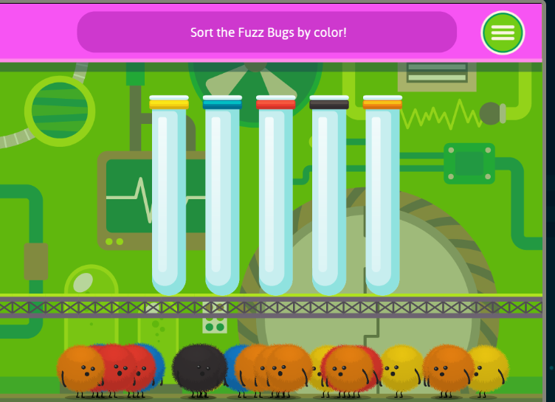  Now collect everyone’s favourite colour and talk about the least and the most popular. Save this to compare with the follow-up activity.  Follow up activity: Complete the Tally Chart and then use this to complete the Block Graph about favourite colours.  Extension: How different were the answers in the class compared to the follow up activity?  Worksheet: Favourite colour tally and bar chart activity sheets TUESDAY | MATHS  Bar model  Play the number bonds game.  (topmarks)  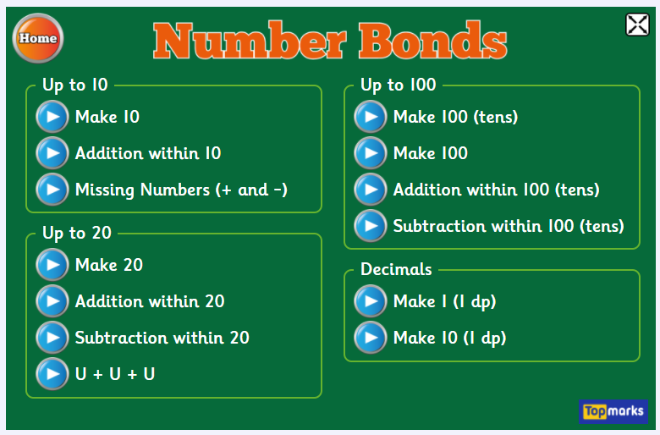  Use the ‘bar model’. learners can then find the number bonds to 20.  Using the worksheet, fill in the missing numbers to complete the bar model.  Worksheet: WEDNESDAY Bar model | MATHS  Part Part Whole.  Play the part part whole game.  https://www.ictgames.com/mobilePage/partPartWhole/index.html  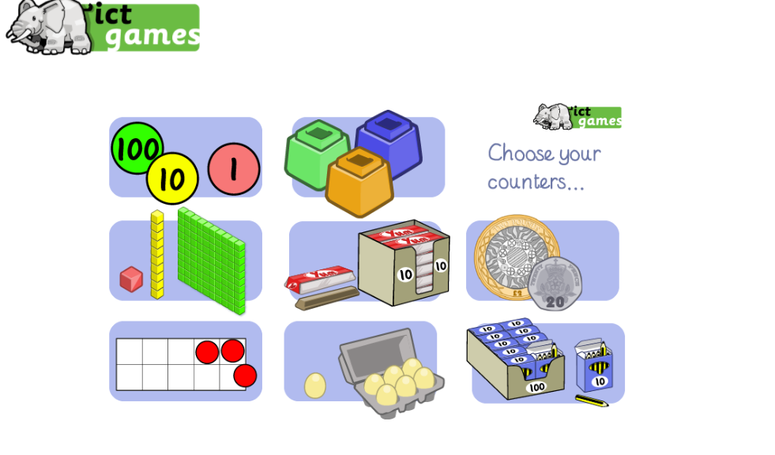  Using the worksheet, fill in the missing numbers to complete the part part whole.  Worksheet: Part Part Whole THURSDAY | MATHS  Adding two-digit numbers.  Purple mash – addition to 20  Using column addition complete the questions on the worksheet.  Worksheet: Addition FRIDAY
Reading:  Books from home  Serial Mash  Books For Topics  Twinkl | Reading Challenge:  Complete an activity for your reading challenge.  Are you close to your award for reading 10, 15 or 25 books?  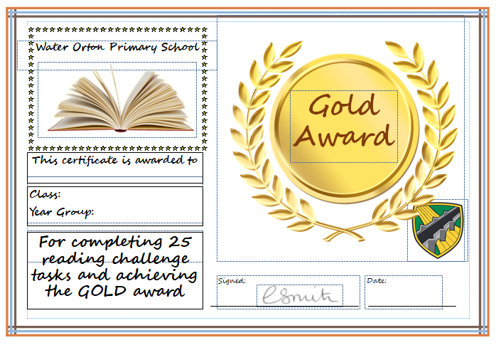 | Reading Challenge:  Complete an activity for your reading challenge.  Are you close to your award for reading 10, 15 or 25 books? | Big Cat E-library  Read and discuss in depth one of your Big Cat books from your e-library.  Download the pdf (click on the 3 dots at the side of the book cover on your bookshelf) and have a go at the related activity or make one up of your own using the guidance at the back of the book if there is no pdf available for your choice. | Big Cat E-library  Read and discuss in depth one of your Big Cat books from your e-library.  Download the pdf (click on the 3 dots at the side of the book cover on your bookshelf) and have a go at the related activity or make one up of your own using the guidance at the back of the book if there is no pdf available for your choice. | Story  Share a story with an adult. Listen carefully and answer questions about the characters, what is happening and the setting. Discuss vocabulary and make predictions about what might happen next.
Topic &  Other Activities  School Website Resources & Videos  BBC Bitesize  Oak Academy | Premier League Stars – Wellbeing  Log onto: Premier League Stars Website  https://plprimarystars.com/competitions  Look at the section: Premier League Wellbeing Stars and watch the introductory video with Lauren Layfield. | Premier League Stars – Wellbeing  Look at the Wellbeing Template and think about the kind of things you would like to do and how you would like to do it. Use the example of a completed template to help you understand how to take on the challenge. | Premier League Stars – Wellbeing  Complete and undertake the different activities. Remember to vary them and think about keeping safe whilst you undertake them. | Premier League Stars – Wellbeing  Complete the checklist and then choose an emoji and write a short paragraph to explain how it made you feel along with some details about yourself and school. | Premier League Stars – Wellbeing  Once you have completed the tasks, you should tick them off on the Wellbeing Week template. You can then submit the template via the Premier League Primary Stars website using the parent/carer entry form. Good luck!
PE  Sport  Physical Exercise | Movement  Look at the compilation clip of different animals moving in different ways.  https://www.bbc.co.uk/bitesize/clips/zdq4d2p  Pick an animal you have seen in the video. Can you move like it? Use your whole body to try to recreate the animals movements accurately.  Now try another animal and so on. | Footprints  Oak Academy KS1 PE Dance Lesson 1 Pathways  https://classroom.thenational.academy/lessons/footprints-an-introduction-to-pathways-cgv3jt | Jack and the Beanstalk  Oak Academy KS1 PE Dance Lesson 2  Storytelling through dance.  https://classroom.thenational.academy/lessons/jack-and-the-beanstalk-an-introduction-to-storytelling-through-dance-70upcd | Co-ordination  Watch the video of the clown juggling scarves.  https://www.bbc.co.uk/bitesize/clips/z7qc87h  Have a go yourself! (If you don’t have scarves, use something else you might have in the house instead – tissues, dusters, cloths!) | Travelling  Oak Academy KS1 PE Dance Lesson 3  Sequence building through dance  https://classroom.thenational.academy/lessons/travelling-an-introduction-to-sequence-building-70wp6e
Storytime | The Quangle Wangle’s Hat by Edward Lear  Read by Miss North  https://www.waterortonprimaryschool.co.uk/stories-by-miss-north-younger-readers/ | Ruby Flew Too!  by Jonathan Emmett  Read by Mrs Smith  https://water-orton-primary-school.primarysite.media/media/ruby-flew-too-read-by-mrs-smith | Six Dinner Sid  by Inga Moore  Read by Miss North  https://www.waterortonprimaryschool.co.uk/stories-by-miss-north-younger-readers/ | Not Now Bernard  by David Mckee  YouTube read by Books Alive  https://www.youtube.com/watch?v=6kXkN2lwGmA | Emily Brown and the Thing by Cressida Cowell  Read by Cressida Cowell  https://www.youtube.com/watch?v=ZKRbK0qU1n8

Hello parents and children.
Here are the daily suggestions for the next 5 days for Reading, Writing, Maths, Topic, PE and a story at the end of the day. As always, you can do them in which ever order you like and pick out the activities you would like to do each day. So you can dip in and out, pick other activities or use your own resources if you prefer. But for those of you who want to you can follow this every day to the letter!
There will only be ‘live’ lessons in the event of a whole bubble closure therefore, there are no live lessons for Elm children currently but you should have lots to do using this timetable as your guide.
Look forward to seeing you back at school soon. We really miss you.
Take care,
Miss North and Mr Dalley

