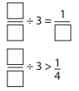
Challenge 3 – Dividing fractions

- 1/12 ÷ 7 =
- 3/21 ÷ 6 =
- Frankie shares 4/5 of a bag of sweets with his 5 friends, what fraction of the bag of sweets will each person get?
- Mr Soong has one quarter of a pizza, he splits it between himself and his two children, what fraction of the pizza do each get?
- Lorraine gave her 4 friends 9/11 of a chocolate bar to share between themselves. David gave 2 friends 16/22 of a chocolate bar to share between themselves. If you wanted more chocolate, who would you want to be friends with and why?
- Alan had 8/15 of a loaf of bread which he shared between his 5 children. What fraction of the loaf of bread did each child get?
- True or false? Explain your answers.
- 2/12 ÷ 6 = 1/6 ÷ 5
- 4/10 ÷ 7 > 3/5 ÷ 7
- 6/9 ÷ 8 > ¼ ÷ 9
- < = > Less than, equal to or more than
- 5/8 ÷ 9 2/9 ÷ 4
- 3/10 ÷ 8 5/8 ÷ 5
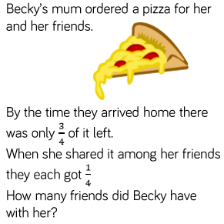
- 1/18 ÷ 4 1/9 ÷ 8

