Challenge 1:
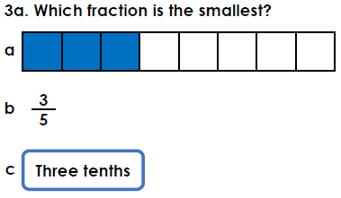
Challenge 2:
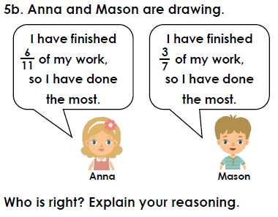
Challenge 3:
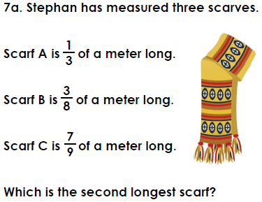

Challenge 1:
Challenge 2:
Challenge 3:

