Week 7  Proposed Timetable for HAZEL CLASS: 2020-21 (Spring Term) All work will be uploaded to the school website. Challenges are available You will have two online sessions per day via Microsoft Teams, every morning and afternoon Please be on time | Day 31 | Day 32 | Day 33 | Day 34 | Day 35
English:  Oak Academy  School Website  Purple Mash  Letter Join  BBC Bitesize | ENGLISH  Homophones and Confusing Words  P20&21 of English section of paper pack | ENGLISH  Synonyms and Antonyms  P22&23 of English section of paper pack  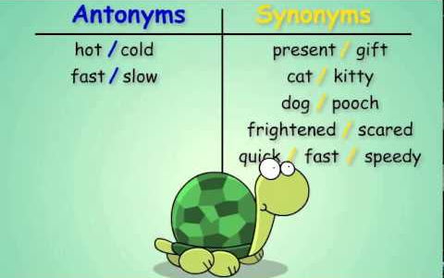 | ENGLISH  Text Types  P24&25 of English section of paper pack | ENGLISH  GPS  Answer the ‘Think…Solve…Apply’ style questions. If you come across something you aren’t sure about, research the grammatical term e.g. modal verbs to help yourself | ENGLISH  Creative Writing  Write an ancient myth set in an ancient civilisation of your choice.  Follow the instructions on the right-hand side of the sheet.
Maths:  BBC Bitesize White Rose  School Website  Oak Academy  Purple Mash  Mathletics  NRich  Times Table Rock Stars | MATHS  Read and write decimal numbers as fractions  https://www.youtube.com/watch?app=desktop&v=1Gkj800MXXE  Complete the activity – ‘Decimals and Fractions’.  There is an additional challenge available for afterwards if you like! Find it in the ‘Challenges’ folder. | MATHS  Associate a fraction with division and calculate decimal fraction equivalents for a simple fraction  https://www.youtube.com/watch?v=guBVW5PiHLs  Decimal fractions equivalent sort (Venn diagram).  Choose your own level of difficulty (1, 2 or 3 star) and self-mark to see how you got on | MATHS  Multiply one-digit numbers with up to two decimal places by whole numbers  https://www.youtube.com/watch?v=tsOibhsgYoQ  https://www.youtube.com/watch?app=desktop&v=yRpFTycg2z0  Choose your own difficulty level when completing the activity. Self-mark your answers to see how well you did | MATHS  Multiply and divide whole numbers and those involving decimals by 10, 100 and 1000 (practice)  https://www.youtube.com/watch?v=QIz_uBz9woM  https://www.youtube.com/watch?v=6fLNcGSa_L4  Choosing your own difficulty level, complete the activity which involves finding missing numbers | MATHS  Drawing upon know facts  Complete the activity – this involves using facts you already know to find out ones you don’t know yet.  There is a step-by-step guide at the top of the sheet  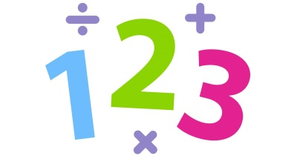
Reading:  Audio-books  Magazines  Purple Mash  Books | READING  Cogheart  Read Chapter 23 of Cogheart by Peter Bunzl | READING  Cogheart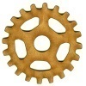  Read Chapter 24 of Cogheart by Peter Bunzl | READING  Cogheart  Read Chapter 25 of Cogheart by Peter Bunzl | READING  Cogheart  (FINAL CHAPTER)  Read Chapter 26 of Cogheart by Peter Bunzl | READING  Free Reading Friday!  Read for pleasure. Read something that you enjoy for 20 minutes.
Topic &  Other Activities  School Website Resources & Videos  BBC Bitesize  Oak Academy | TOPIC & OTHER ACTIVITIES  PSHE  Set up your ‘Healthy Living’ journal  https://www.youtube.com/watch?v=UxnEuj1c0sw  Look at the example journals/charts. Create your own to record your food consumption, physical activity and more over the next week. Your journal must include the following: breakfast, lunch, dinner, snacks, physical activity, water consumed, amount of sleep, how you feel at the end of the day and anything else you feel is important | TOPIC & OTHER ACTIVITIES  PSHE  Finding ways to be happy and cope with life’s situations  Life can be tricky at the moment. When we are finding things hard, we need to do as many things as we can that make us happy and enjoy life.  Complete the activity to show what and who make you happy. You can use a combination of drawing and writing.   | TOPIC & OTHER ACTIVITIES  PSHE  Research – Peer pressure  Find out what peer pressure is and how to deal with it.  You can present this work however you like!  Why not…  - Make a poster?  - Make a leaflet?  - Write a paragraph  The following video may be useful to you help you get started…  https://www.youtube.com/watch?v=2Og4rMnT6G0 | TOPIC & OTHER ACTIVITIES  PSHE  Mental Health  At the beginning of February, it was ‘Mental Health Week’.  Choose your own level of difficulty and complete the reading comprehension about Mental Health.  You might like to watch the short video clip before you begin.  https://www.youtube.com/watch?v=UmrUV8v-KQg | TOPIC & OTHER ACTIVITIES  PSHE  Relaxation techniques to be used in times of stress  Try out each of these techniques that you can use in times of stress. That way, when you need them, you will already know what to do!  
PE  Sport  Physical Exercise | PE/SPORT  Physical Challenge #21 –  Can you master the skill?  https://www.youtube.com/watch?v=l7dMbP17M7o | PE/SPORT  Physical Challenge #22 –  Can you master the skill?  https://www.youtube.com/watch?v=bWFuNDPYn40 | PE/SPORT  Physical Challenge #23 –  Can you master the skill?  https://www.youtube.com/watch?v=AZrw79KXqJ4 | PE/SPORT  Physical Challenge #24 –  Can you master the skill?  https://www.youtube.com/watch?v=Ymf0eElJcLg | PE/SPORT  Physical Challenge #25 –  Can you master the skill?  https://www.youtube.com/watch?v=sBrJ7QPw72o
Storytime | STORYTIME  Percy Jackson and the Lightning Thief  Listen to Chapter 16 (audiobook) on YouTube  https://www.youtube.com/watch?v=LPgB6yyGTSE | STORYTIME  Percy Jackson and the Lightning Thief  Listen to Chapter 17 (audiobook) on YouTube  https://www.youtube.com/watch?v=rRUSVc0U0F8 | STORYTIME  Percy Jackson and the Lightning Thief  Listen to Chapter 18 (audiobook) on YouTube  https://www.youtube.com/watch?v=0dUZG2levCQ | STORYTIME  Percy Jackson and the Lightning Thief  Listen to Chapter 19 (audiobook) on YouTube  https://www.youtube.com/watch?v=4BdnQee7nTQ | STORYTIME  Percy Jackson and the Lightning Thief  Listen to Chapter 20 (audiobook) on YouTube  https://www.youtube.com/watch?v=ECE7NOM04-0
SECOND WEEK USING PAPER PACKS
Hello Hazel Class! Our topic for this term is ‘Ancient Greece’! I hope you are enjoying it so far.

Here is your home learning timetable containing the information you will need for Days 31-35. You can do your tasks in whichever order you like. You can dip in and out, pick other activities in place of the ones we have suggested, or use your own resources if you prefer. But for those of you who want to, you can follow this every day to the letter - just like when you are at school! It’s up to you and the adults at home who are helping you. The ‘Challenge Work’ folder will be available as always and other challenges are mentioned above.
Feel free to send me your work so I can see how well you have done. You can use your WOP account to send it over or ask your parents if they can send it over.
Have a great week everyone!
Miss Thompson

P.S – Try to watch CBBC Newsround every day. There are lots of activities you can do on this website too including quizzes! Enjoy!

IMPORTANT – Remember, your Y5&6 Ancient Greece Homework is now available on the school website. Have you made a start? Finished pieces of homework should be sent to Miss Thompson via your school email account or your parents can email it if that is easier.

OTHER INFORMATION – DON’T FORGET TIMES TABLE ROCK STARS

