English – Day 6
LO: To infer

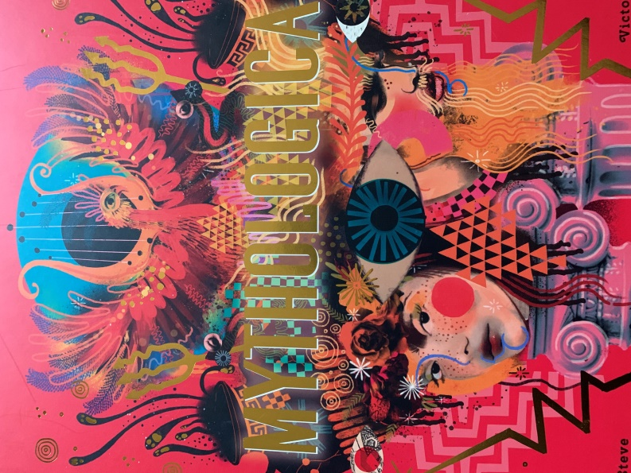

What can you infer from looking at the front cover of this book?

What do you think this book is about?

What can you see? What do you think it represents? Does each picture/symbol have a meaning? If so, what could it be?

