Week 4  Proposed Timetable for HAZEL CLASS: 2020-21 (Spring Term) All work will be uploaded to the school website. Challenges are available You will have two online sessions per day via Microsoft Teams, every morning and afternoon Please be on time | Day 16 | Day 17 | Day 18 | Day 19 | Day 20
English:  Oak Academy  School Website  Purple Mash  Letter Join  BBC Bitesize | ENGLISH  Myths (Openings)  Read the examples – myth openings.  This will give you a really good idea of how to write an opening for a myth. Highlight/underline anything you think is good in the example that you could use in your own opening of your myth that you planned.  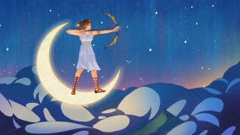 | ENGLISH  Write your opening - myth  Listen to some of the beginnings of the myths using the following link - https://www.bbc.co.uk/teach/school-radio/ks2-ancient-greece/zk73nrd  Write your opening for your myth – make it detailed and ensure you use good vocabulary and punctuation. | ENGLISH  Writing - myth  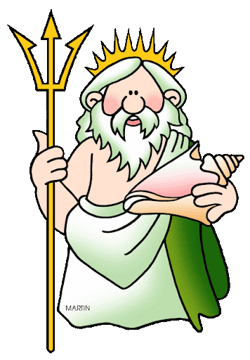  Write the rest of your myth. Remember to paragraph effectively and use a range of writing skills including a range of punctuation, a range of sentences openers, good vocabulary etc.  Challenge: can you include some speech?  Why not record yourself reading your story and ask your parent to email it to Miss Thompson? | ENGLISH  Create your own ‘Mythical Beast’  Create your own mythical beast (sheet available).  They might have multiple heads or lots of arms. They might be half one animal and half another e.g. half crocodile and half tiger! They could live in a cave, isolated from people, or they could roam the streets of ancient Greece, causing chaos wherever they go. Does your creature enjoy doing terrible things or do they wish they could change? | ENGLISH  Character description  Can you write a description of your mythical beast that you created yesterday?  Remember to use a wide  vocabulary and include lots of descriptive language.  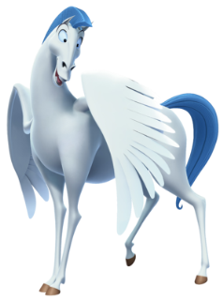
Maths:  BBC Bitesize White Rose  School Website  Oak Academy  Purple Mash  Mathletics  NRich  Times Table Rock Stars | MATHS  Equivalent Fractions  Watch these two videos about equivalent fractions and then complete the worksheet (choose your difficulty)  https://www.youtube.com/watch?v=jlpnMrPFSUw  https://www.youtube.com/watch?v=oFVzcnJfYkg | MATHS  Comparing and Ordering Fractions  Watch these two videos about comparing and ordering fractions and then complete the worksheet (choose your difficulty)  https://www.youtube.com/watch?v=u_QTuWj107o  https://www.youtube.com/watch?v=i2PfHDs88YE | MATHS  Converting improper fractions to mixed numbers  Watch these two videos about converting improper fractions to mixed numbers and then complete the worksheets  https://www.youtube.com/watch?v=_2yRsab7NXk  https://www.youtube.com/watch?v=EpXCr2iax5E | MATHS  Converting mixed numbers to improper fractions  Watch the two videos about converting mixed numbers to improper fractions and then complete the worksheet  https://www.youtube.com/watch?v=LB3-IFkgpBk  (In this video, they say ‘fourths’ but we would say ‘quarters’)  https://www.youtube.com/watch?v=96NOYcnmThU | MATHS  Arithmetic  Complete the correct test for your year group. Don’t treat it like a test today though – find out how to answer any questions you aren’t sure about to improve your knowledge.  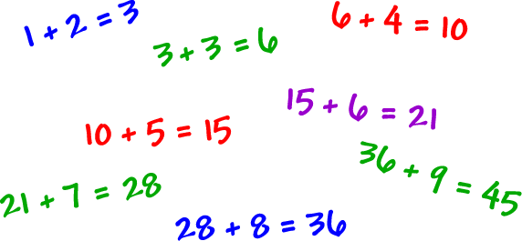
Reading:  Audio-books  Magazines  Purple Mash  Books | READING  Cogheart  Read Chapter 11 of Cogheart by Peter Bunzl | READING  Cogheart  Read Chapter 12 of Cogheart by Peter Bunzl | READING  Cogheart  Read Chapter 13 of Cogheart by Peter Bunzl | READING  Cogheart  Read Chapter 14 of Cogheart by Peter Bunzl | READING  Free Reading Friday!  Read for pleasure. Read something that you enjoy for 20 minutes.
Topic &  Other Activities  School Website Resources & Videos  BBC Bitesize  Oak Academy | TOPIC & OTHER ACTIVITIES  Science - Systems in the Body  Complete the activity sheet about the three body systems. Carry out any necessary research as you go along   | TOPIC & OTHER ACTIVITIES  Science – The Circulatory System  Watch the videos https://www.youtube.com/watch?v=pjOxpLEynIE and https://www.youtube.com/watch?v=-s5iCoCaofc then complete the labelling activities | TOPIC & OTHER ACTIVITIES  Science – The Digestive System (Revision)  Watch the video about the human digestive system - https://www.youtube.com/watch?v=ZBZWgrfZFbU then name the parts of the digestive system and their function (activity sheet) | TOPIC & OTHER ACTIVITIES  Science – Transporting Water and Nutrients Around The Body  Watch the video - https://www.youtube.com/watch?v=eSEYPO30AN0  Find out where different nutrients are needed in the body | TOPIC & OTHER ACTIVITIES  Science – The Food Pyramid  - Find out what the main food groups are  - Label each level of the food pyramid  - Put the various food items in the correct level on the food pyramid  (If you don’t have a printer, draw it )
PE  Sport  Physical Exercise | PE/SPORT  Physical Challenge #6 – Toilet Paper On Your Head!  Can you master the skill?  https://www.youtube.com/watch?v=Y4RrHB92fck | PE/SPORT  Physical Challenge #7 – The Stick  Can you master the skill?  https://www.youtube.com/watch?v=kncujZdbMnE | PE/SPORT  Physical Challenge #8 – One Leg Stand Up  Can you master the skill?  https://www.youtube.com/watch?v=YBJpUYlYUrM | PE/SPORT  Physical Challenge #9 – Get Down, Get Up  Can you master the skill?  https://www.youtube.com/watch?v=QUM3RlKkcvc | PE/SPORT  Physical Challenge #10 – The Paper  Can you master the skill?  https://www.youtube.com/watch?v=nAsTpX3rJjk
Storytime | STORYTIME  Percy Jackson and the Lightning Thief  Listen to Chapter 1 (audiobook) on YouTube  https://www.youtube.com/watch?v=IfPe74OISU4 | STORYTIME  Percy Jackson and the Lightning Thief  Listen to Chapter 2 (audiobook) on YouTube  https://www.youtube.com/watch?v=BddoN4Ja14U | STORYTIME  Percy Jackson and the Lightning Thief  Listen to Chapter 3 (audiobook) on YouTube  https://www.youtube.com/watch?v=R7sJ6Vmy_Qw | STORYTIME  Percy Jackson and the Lightning Thief  Listen to Chapter 4 (audiobook) on YouTube  https://www.youtube.com/watch?v=M2LNyTZZajE | STORYTIME  Percy Jackson and the Lightning Thief  Listen to Chapter 5 (audiobook) on YouTube  https://www.youtube.com/watch?v=H-r3_wOzwhU
Hello Hazel Class! Our topic for this term is ‘Ancient Greece’! I hope you are enjoying it so far.

Here is your home learning timetable containing the information you will need for Days 16-20. You can do your tasks in whichever order you like. You can dip in and out, pick other activities in place of the ones we have suggested, or use your own resources if you prefer. But for those of you who want to, you can follow this every day to the letter - just like when you are at school! It’s up to you and the adults at home who are helping you. The ‘Challenge Work’ folder will be available as always and other challenges are mentioned above.

Feel free to send me your work so I can see how well you have done. You can use your WOP account to send it over or ask your parents if they can send it over.

Have a great week everyone!

Miss Thompson

P.S – Try to watch CBBC Newsround every day. There are lots of activities you can do on this website too including quizzes! Enjoy!

IMPORTANT – Remember, your Y5&6 Ancient Greece Homework is now available on the school website. Have you made a start?

