Week 2  Proposed Timetable for HAZEL CLASS: 2020-21 (Spring Term) All work will be uploaded to the school website. Challenges are available You will have two online sessions per day via Microsoft Teams, every morning and afternoon Please be on time | Day 11 | Day 12 | Day 13 | Day 14 | Day 15
English:  Oak Academy  School Website  Purple Mash  Letter Join  BBC Bitesize | ENGLISH  Looking at a good example (fact file)  Look at the fact file example about David Walliams. Read the example (3 star) and identify the following: headings, sub-headings, key facts, topical language and pictures.  Look back at your notes from the previous lesson (god/goddess research) and plan a fact file. Think about the subheadings (and other features) you can use and decide on a layout. | ENGLISH  Writing a good introduction for your fact file  Look back at the introduction paragraph on the David Walliams fact file. Write your own good-quality introduction for your fact file. Remember, this must be about the god you chose to research. | ENGLISH  Writing the rest of your fact file  Use your research/notes and plan to help write the rest of your factfile about your chosen Greek god/goddess.  Challenge: include a glossary  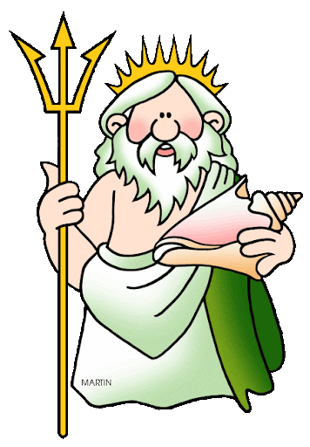 | ENGLISH  An introduction to myths  Read the story of Orpheus and Eurydice. This story is a myth – myths usually have a main character (hero), a quest, a challenge set by a god and a mythical beast.  Watch the following three videos to give yourself a better idea about Greek myths…  https://www.youtube.com/watch?v=JWdy2EGjJ9E  https://www.youtube.com/watch?v=rNk-zV2T7bI  https://www.youtube.com/watch?v=xQuAUBX5xBw | ENGLISH  Plan your own myth  Using the Greek Myth Story Dice, plan your own myth. A storyboard is a good tool to use when planning a story so it will work for myths.  Choose your setting, main character, mythical beast and Greek god/goddess.  Remember, every good myth will feature a challenge set by god/a ‘quest’.
Maths:  BBC Bitesize White Rose  School Website  Oak Academy  Purple Mash  Mathletics  NRich  Times Table Rock Stars | MATHS  Finding the mean/average  Watch the video clip then complete the activity sheet, choosing your own difficulty level. You may need to do a bit of additional research if you choose one of the harder sheets. It is supposed to be tricky! Remember to self-mark to see how you did.  https://www.youtube.com/watch?v=7Zni81m_7wM | MATHS  Mean, median, mode and range  Begin by looking at the help poster and watching the video - https://www.youtube.com/watch?v=A1mQ9kD-i9I  Then, complete the ‘mode, mean and range of winter weather’ activity and then self-mark your answers. | MATHS  Pie charts  Watch the video about pie charts - https://www.youtube.com/watch?v=Ruc9n6ho3l4  Answer the questions about the various pie charts. There are lots of sheets to choose from e.g. favourite animals etc. Challenge – pie chart SATs questions. | MATHS  Line graphs  Watch the video about line graphs - https://www.youtube.com/watch?v=0WkqfJBfXic  Answer the questions about the line graphs. You can choose middle difficulty or higher – no easy option today!  You could even do both activities for extra practice | MATHS  Arithmetic  Complete Core Arithmetic Test 6.  If you would like a challenge, complete Extension Arithmetic Test 4 afterwards.  If you get stuck on any of the questions, research how to work out the answer
Reading:  Audio-books  Magazines  Purple Mash  Books | READING  Earthquakes Comprehension  Choose your own level of difficulty and complete the questions. | READING  FA Cup Comprehension  Choose your own level of difficulty and complete the questions. | READING  Lottery Win Comprehension  Choose your own level of difficulty and complete the questions. | READING  The Great Plague  Choose your own level of difficulty and complete the questions. | READING  Free Reading Friday!  Read for pleasure. Read something that you enjoy for 20 minutes.
Topic &  Other Activities  School Website Resources & Videos  BBC Bitesize  Oak Academy | TOPIC & OTHER ACTIVITIES  History & Geography  Read through the slides about ‘city states’ including Athens and Sparta.  Complete the following worksheets – 2A, 2B (which form one activity).  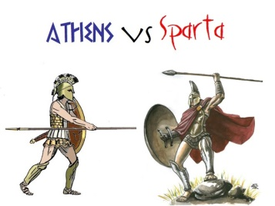 | TOPIC & OTHER ACTIVITIES  History & Geography  Read through the slides about ‘city states’ including Athens and Sparta again.  Complete activity 2C. You may need to carry out some additional research for parts that aren’t covered in the slides. | TOPIC & OTHER ACTIVITIES  History & Geography  This topic lesson will really help with your English learning this week as it is about gods/goddesses. Read the slides about the ‘Olympian Gods’. Complete worksheet 4A or 4B. There is also a game that you could have a go at if you have access to a printer or make your own game linked to this if not. It would be a good idea to choose gods/goddesses you aren’t learning about in English | TOPIC & OTHER ACTIVITIES  History & Geography  Watch the two video clips from the London 2012 Olympic Games.  https://www.youtube.com/watch?app=desktop&v=gKJDjg4ebNQ  https://www.youtube.com/watch?app=desktop&v=OJbcJVmgvz4  Read the information about the Olympic Games too and look at the photos on the vases - can you work out which sport each vase represents? Get someone to take some photos of you acting out different sports. | TOPIC & OTHER ACTIVITIES  History & Geography  Compare the ‘Ancient’ and ‘Modern’ Olympic Games.  Choose your own level of difficulty from the worksheets available and self-mark it when you have finished to see how you got on.  
PE  Sport  Physical Exercise | PE/SPORT  Physical Challenge #1 – The Shoe  https://www.youtube.com/watch?v=0RWSwo1FziM  Once you have mastered the skills, see if you can get quicker at doing them! | PE/SPORT  Physical Challenge #2 - Equilibrium  https://www.youtube.com/watch?v=M154Ua-CwBk | PE/SPORT  Physical Challenge #3 – Shoulder Twist  https://www.youtube.com/watch?v=SBQX6mU5YpQ | PE/SPORT  Physical Challenge #4 – Body Equilibrium  https://www.youtube.com/watch?v=IaNTHCDOSQg | PE/SPORT  Physical Challenge #5 – Legs Through Arms  https://www.youtube.com/watch?v=FlmdgsuxZ1Q
Storytime | STORYTIME  Read…  Posy Pooch | STORYTIME  Read…  Terry Tetch | STORYTIME  Read…  Miss Tutelage | STORYTIME  Read…  Harriet Hurry | STORYTIME  Read…  Peter Pong
Hello Hazel Class! Our topic for this term is ‘Ancient Greece’! I am sure you will find it interesting already.

Here is your home learning timetable containing the information you will need for Days 11-15. You can do your tasks in whichever order you like. You can dip in and out, pick other activities in place of the ones we have suggested, or use your own resources if you prefer. But for those of you who want to, you can follow this every day to the letter - just like when you are at school! It’s up to you and the adults at home who are helping you. The ‘Challenge Work’ folder will be available as always and other challenges are mentioned above.

Feel free to send me your work so I can see how well you have done. You can use your WOP account to send it over or ask your parents if they can send it over.

Have a great week everyone!

Miss Thompson

P.S – Try to watch CBBC Newsround every day. There are lots of activities you can do on this website too including quizzes! Enjoy!

IMPORTANT – Please look out for the new ‘Year 5&6 Homework’ based on Ancient Greece. This will be sent out to parents soon or uploaded to the website. Keep an eye out for it. You can make a really decent start on it whilst learning at home. The curriculum overview will be released soon too so you know what we will be learning in Spring Term.

PLEASE NOTE – YOU HAVE ALSO BEEN ADDED TO ANOTHER MICROSOFT ‘TEAM’ – ‘BEECH & HAZEL’. This is because there will be occasions where we want both classes to attend the same session, such as PE or other one-off sessions

