KS2 Activities
Activity 1 - Scatagories
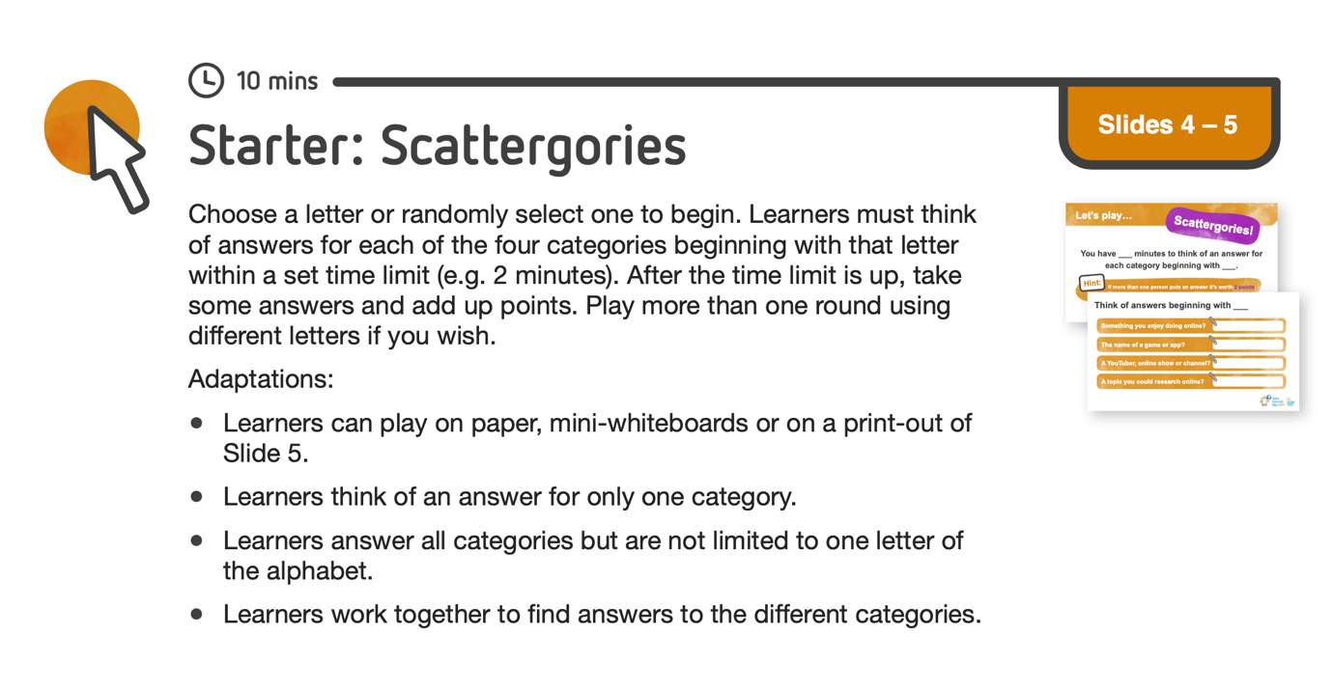
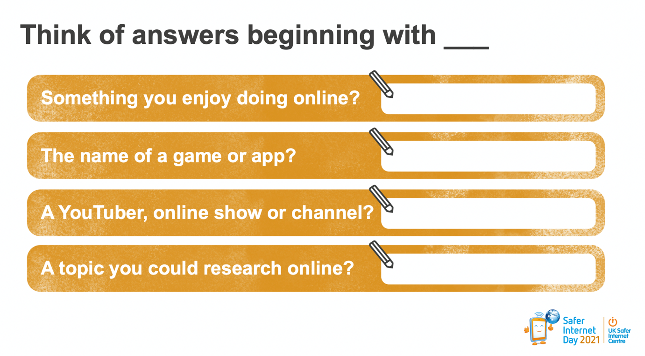

Activity Two - ‘Trust It or Check It’ video
Watch the video using the link below.
https://www.saferinternet.org.uk/safer-internet-day/safer-internet-day-2021/i-am-educator/work-7-11s/virtual-assembly-7-11s

Activity Three - Detective
Try to complete all of the activities before the end of the day.



