Week 5  Proposed Timetable for HAZEL CLASS: 2020-21 (Spring Term) All work will be uploaded to the school website. Challenges are available You will have two online sessions per day via Microsoft Teams, every morning and afternoon Please be on time | Day 21 | Day 22 | Day 23 | Day 24 | Day 25
English:  Oak Academy  School Website  Purple Mash  Letter Join  BBC Bitesize | ENGLISH  Determiners  https://www.youtube.com/watch?v=v40NP-HyBrE  Complete the activity on determiners, choosing the 1, 2 or 3 star activity.  Self-mark to see how you did  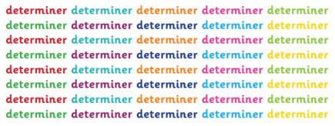 | ENGLISH  Pronouns  https://www.youtube.com/watch?v=CwQjSsa8VQE  Complete the activity on pronouns, choosing the 1, 2 or 3 star activity.  Self-mark to see how you did  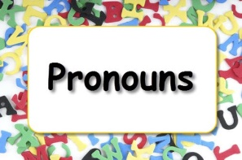 | ENGLISH  Personal and Possessive Pronouns  https://www.youtube.com/watch?v=CYXDr_vHiik  https://www.youtube.com/watch?v=KIrdc1gkHFs  Again, complete the activity, choosing your difficulty and self-mark | ENGLISH  Apostrophes (singular and plural possession)  https://www.youtube.com/watch?v=zNFPnVz7JB4  Complete the apostrophes activity – choose the sentences (Set 1 or 2 – or both!) to edit. A challenge is available at the bottom of the sheet and a mini-test is available in the challenge section on the website | ENGLISH  Standard English  Lots of people get confused whether they should use ‘did’ or ‘done’ in sentences.  Choose your level of difficulty and answer the questions. Don’t forget to self-mark afterwards to see how you got on  
Maths:  BBC Bitesize White Rose  School Website  Oak Academy  Purple Mash  Mathletics  NRich  Times Table Rock Stars | MATHS  Adding and subtracting fractions with different denominators  https://www.youtube.com/watch?v=xNsyNwAkqfk  Complete the activity. There is an easier option or there is a word problem option which is harder, but still has three levels of difficulty to choose from  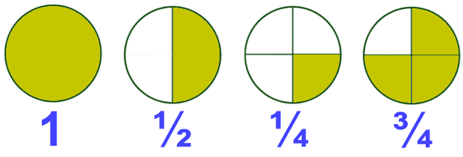 | MATHS  Multiplying proper fractions and mixed numbers by whole numbers  https://www.youtube.com/watch?v=B8LVDxQB_LQ  https://www.youtube.com/watch?v=6j8uXaTmaP0  Multiply the fractions and whole numbers using diagrams to support you | MATHS  Multiply simple pairs of proper fractions, writing the answer in its simplest form  https://www.youtube.com/watch?v=H3ZY65icKmw  Choose between the 1* or 3* activity.  Remember to write your fraction in its simplest form | MATHS  Divide proper fractions by whole numbers  https://www.youtube.com/watch?v=AwSMewrnQXg  We can also remember this strategy using the saying ‘flip the action; flip the fraction!’  Complete the ‘dividing fractions’ activity – normal or harder depending on how confident you feel | MATHS  Calculating with fractions  Use all of the knowledge you have gained this week to help you answer the ‘Calculating with Fractions’ activity. On this sheet, A is the easiest, B is of medium difficulty and C/D are the most difficult.  If you struggle, you can re-watch the videos from earlier in the week  You must also choose one of the ‘Challenges’ at the bottom of this worksheet
Reading:  Audio-books  Magazines  Purple Mash  Books | READING  Cogheart  Read Chapter 15 of Cogheart by Peter Bunzl | READING  Cogheart  Read Chapter 16 of Cogheart by Peter Bunzl | READING  Cogheart  Read Chapter 17 of Cogheart by Peter Bunzl | READING  Cogheart  Read Chapter 18 of Cogheart by Peter Bunzl | READING  Free Reading Friday!  Read for pleasure. Read something that you enjoy for 20 minutes.
Topic &  Other Activities  School Website Resources & Videos  BBC Bitesize  Oak Academy | TOPIC & OTHER ACTIVITIES  Science – Pulse Rate  https://www.youtube.com/watch?v=tF9-jLZNM10  https://www.youtube.com/watch?v=fn66HmzJz6g  Measure your own pulse (heartbeat) and record the information in the table after each exercise, completing the appropriate maths calculations as you go along | TOPIC & OTHER ACTIVITIES  Science – Recording Pulse  https://www.youtube.com/watch?v=RiWr69OzfPo  Design and conduct a simple experiment to see how your pulse changes after different activities.  Record your information in a graph/chart. Use the template provided or create your own | TOPIC & OTHER ACTIVITIES  Science – Drugs and Alcohol (Part 1)  https://www.youtube.com/watch?v=C3Na592f9oc  Label the body with the effects of different substances on different body parts | TOPIC & OTHER ACTIVITIES  Science – Drugs and Alcohol (Part 2)  https://www.youtube.com/watch?v=y2Rgxm7Vvi8  Label the body with the effects of alcohol on different parts of the body | TOPIC & OTHER ACTIVITIES  Science – The Dangers of Smoking  Read the PowerPoint information.  Complete the activity show what effect smoking has on different parts of the body  
PE  Sport  Physical Exercise | PE/SPORT  Physical Challenge #11 –  Can you master the skill?  https://www.youtube.com/watch?v=uQ9ZX6bS-C8 | PE/SPORT  Physical Challenge #12 –  Can you master the skill?  https://www.youtube.com/watch?v=EN9Q2Huj32Q | PE/SPORT  Physical Challenge #13 –  Can you master the skill?  https://www.youtube.com/watch?v=aB0WnNZyzCY | PE/SPORT  Physical Challenge #14 –  Can you master the skill?  https://www.youtube.com/watch?v=Flbo6rfHVh8 | PE/SPORT  Physical Challenge #15 –  Can you master the skill?  https://www.youtube.com/watch?v=8g2bA6sgcEg
Storytime | STORYTIME  Percy Jackson and the Lightning Thief  Listen to Chapter 6 (audiobook) on YouTube  https://www.youtube.com/watch?v=w1pxCBCWSC0 | STORYTIME  Percy Jackson and the Lightning Thief  Listen to Chapter 7 (audiobook) on YouTube  https://www.youtube.com/watch?v=vQYpWWvMLKg | STORYTIME  Percy Jackson and the Lightning Thief  Listen to Chapter 8 (audiobook) on YouTube  https://www.youtube.com/watch?v=HPuscRdqoVA | STORYTIME  Percy Jackson and the Lightning Thief  Listen to Chapter 9 (audiobook) on YouTube  https://www.youtube.com/watch?v=SpGmU7lFars | STORYTIME  Percy Jackson and the Lightning Thief  Listen to Chapter 10 (audiobook) on YouTube  https://www.youtube.com/watch?v=0CXxEFzz3K0
Hello Hazel Class! Our topic for this term is ‘Ancient Greece’! I hope you are enjoying it so far.

Here is your home learning timetable containing the information you will need for Days 21-25. You can do your tasks in whichever order you like. You can dip in and out, pick other activities in place of the ones we have suggested, or use your own resources if you prefer. But for those of you who want to, you can follow this every day to the letter - just like when you are at school! It’s up to you and the adults at home who are helping you. The ‘Challenge Work’ folder will be available as always and other challenges are mentioned above.

Feel free to send me your work so I can see how well you have done. You can use your WOP account to send it over or ask your parents if they can send it over.

Have a great week everyone!

Miss Thompson

P.S – Try to watch CBBC Newsround every day. There are lots of activities you can do on this website too including quizzes! Enjoy!

IMPORTANT – Remember, your Y5&6 Ancient Greece Homework is now available on the school website. Have you made a start? Finished pieces of homework should be sent to Miss Thompson via your school email account or your parents can email it if that is easier.

OTHER INFORMATION – DON’T FORGET TIMES TABLE ROCK STARS

